THE CHRONICLE
RALEIGH-WAKE COUNTY CHAPTER #3689
http:AARPchapter3689.weebly.com
aarp3689@gmail.com
Kelly Vick - Editor
July – August 2022
Speaker for Today  Devin Ross  ONE Wake  Housing for Seniors  In Wake County  **************  The Speaker in July was  Professor Dr. Brian McAdoo  Duke University  “Natural Disasters in 21st Century”  ******************************  Chapter Officers  Co-Presidents  Gayle Gayton  Willi Webb  Vice President  Cordelia Blackwell  Co-Secretaries  Hannah Gathings  Claude Lee  Pat Toothman  Gwenn Weaver  Co-Treasurers  Cynthia Bradley  Claudia Harris  Nominating  Allan Younger  ******************************  Committees  Community Service (Oweida Cole)  Fundraising (Lorrie Berlenbach)  Legislative (Karen Clark)  Membership (Karen Youmans)  Program (Allan Younger)  Sunshine (Claude Lee)  Telephone (Pat Toothman)  Staff Coordinates  Ambassador (James Hines)  Historian (Thelma Blake)  Newsletter (Kelly Vick)  Reflections (Grace Krishnamurty)  Webmaster (Claudia Harris) |  |  | MESSAGE FROM OUR VICE PRESIDENT  (Cordelia Blackwell)  ♪♪♫ Getting to know you – getting to know all about you… ♫♪♪  It seems as if our members like the idea of getting to know each other better. So let’s find out some interesting things about our Sunshine Committee Chairperson, Claude Lee.  Cordelia: Where did you grow up and how did you get to the Raleigh area?  Claude: I grew up here in Raleigh. I lived in Chavis Heights and Kingwood Forest, both located in Southeast Raleigh. I attended elementary, middle school, high school, St. Augustine’s University and North Carolina State University.  Cordelia: Did you come from a small or large family and tell us about your family.  Claude: I came from a family of eight. I had three younger brothers and two sisters. I was the 2nd eldest of my siblings. My eldest sister is currently retired, divorced and resides in Raleigh. Two of my brothers are currently retired and married (one brother lives in Knightdale and the other brother lives in Louisburg). My younger brother lives in Greensboro; single and is a technology teacher at a high school in the Guilford County Public School System. We lost our younger sister in August 2014. We lost our mother in February 2010 and father in November 2017. With both parents being deceased, unfortunately it has been quite difficult for us to fellowship during the holidays.  Cordelia: You have such beautiful penmanship, tell us who taught you to write and about your educational background.  Claude: I always receive compliments on my penmanship. I had an amazing 1st grade teacher (Ms. Wallace) that taught all her students to write cursive. We practice writing all the letters lower and upper case. After regular practice my penmanship was perfected. In regards to my educational background I attended St. Augustine’s College (University) with a major in Social Studies Education and minor in Political Science/BA. I also attended Grad School at North Carolina State University with a major concentration in Counseling/Personnel Services and minor in Psychology/MED. I have also taken post graduate courses at North Carolina A&T State University. (Interview Continued on page 6)
COMMITTEE REPORTS

SUNSHINE
Birthday cards were mailed to members listed below who have birthdays in July and August. A sympathy card was mailed to Cordelia Blackwell for the death of her brother; encouragement cards were mailed to James Hines and Ilse Anke. A thank you card was received from Barbara Faison’s daughter for the death of Barbara Faison. If you know of anyone who is ill, a bereaved family or you are having your “90th Milestone Birthday”, please call Claude Lee (919-971-3317) or e-mail him at claudealeejr@gmail.com.
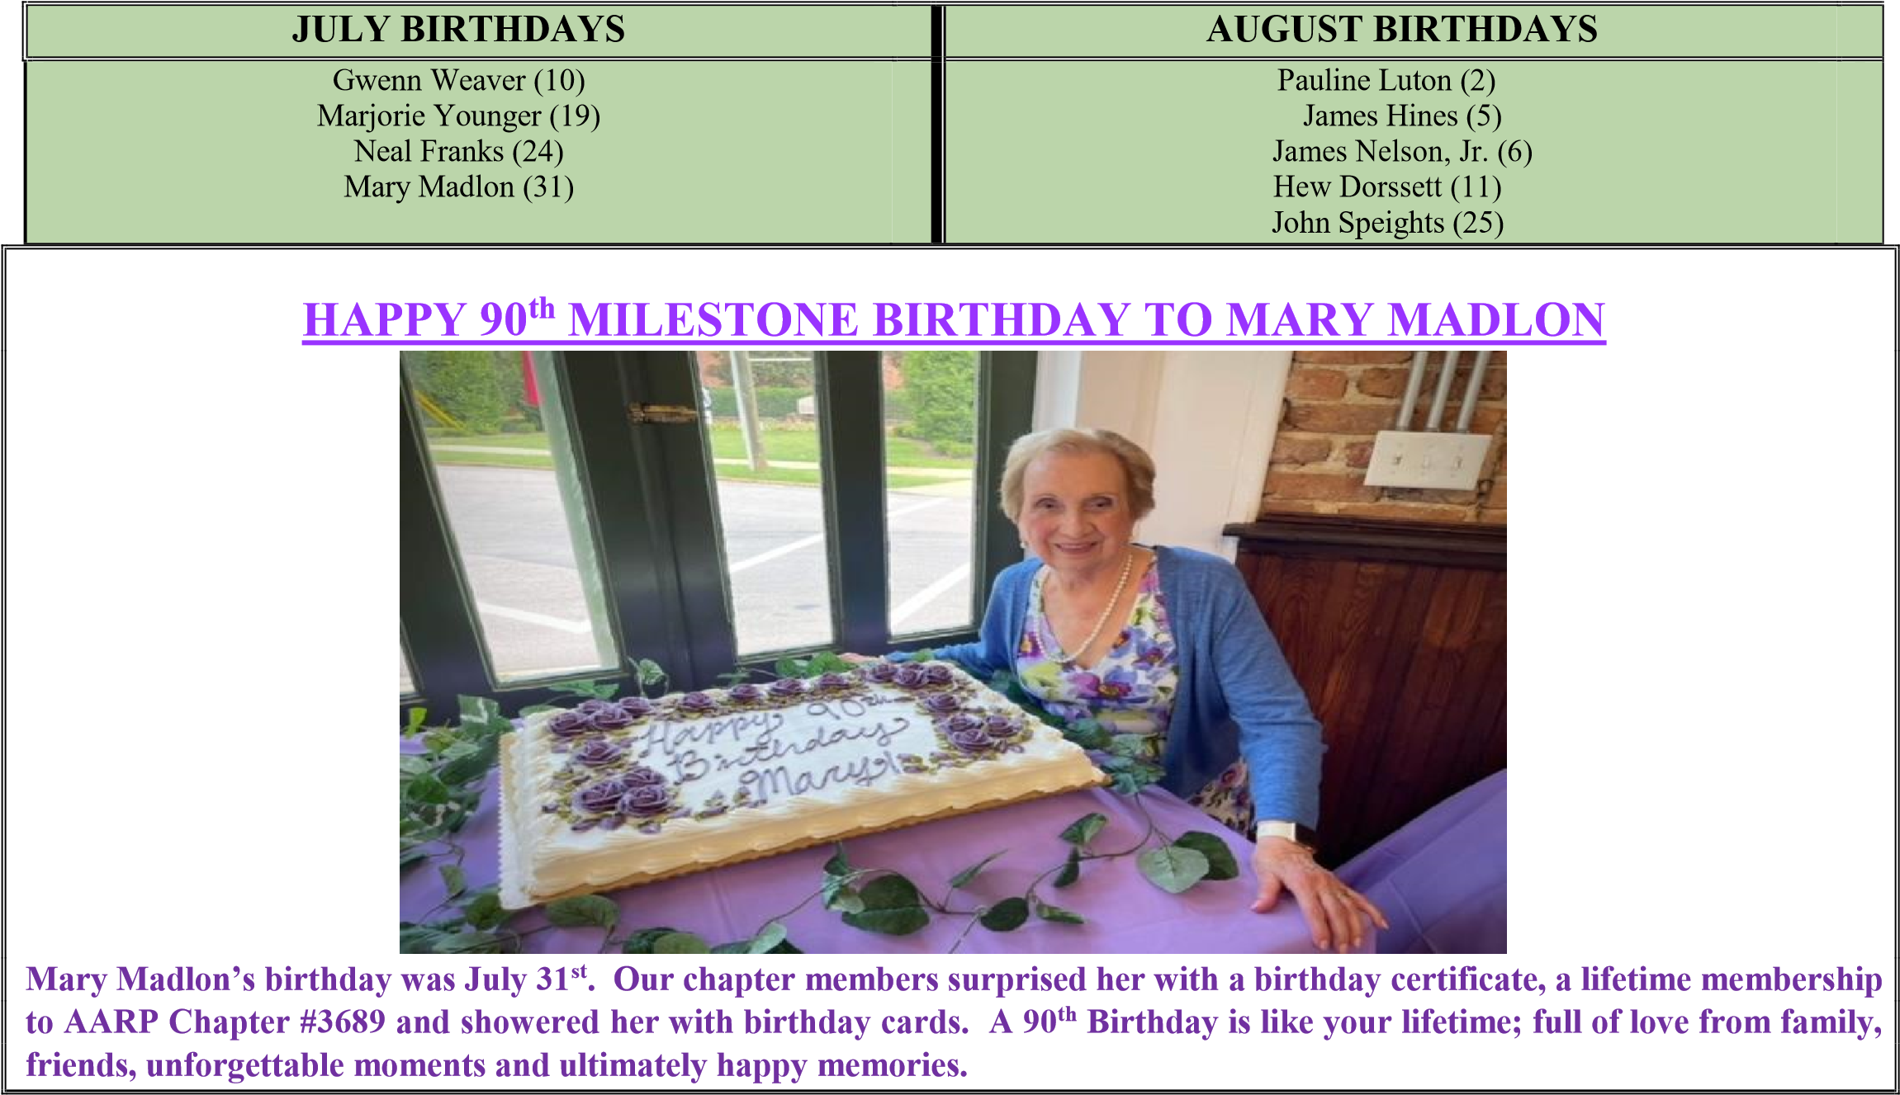

COMMUNITY SERVICE
"Do all the good you can, by all the means you can, in all the ways you can, at all the times you can, to all the people you can, as long as ever you can." - John Wesley

The Community Service Committee strives to "do all the good we can" lately under the present circumstances by continuously delivering clothing as well as bed linens to different organizations; in addition to volunteering at the Food Pantry.

As school has already begun in some parts of our city and others are about to open, we're again soliciting your help to do what you can by donating school supplies. Below is the elementary school and classroom supply list:
#2 Pencils  Red, Black & Blue pens  Wide Ruled Paper  Composition Notebooks  Spiral Notebooks | Glue Sticks  3 Ring Binder Index Cards  Crayola Crayons  Highlighters | Scissors  Pink Erasers  Disinfecting Wipes  Tissues  Medium Shoe Boxes | Pencil Cases  Children’s Dictionary  Elmer’s Glue  Folders with pockets
We would like to collect these items on September 9th at Kohl’s parking lot. Please note that because of the traffic flow, we will relocate further over from the usual place. You'll see us.........................."Don't let yesterday take up too much of today" - Will Rogers

NOMINATING
We have three vacancies. (1) Co-Presidents – These two positions will be working in partnership with each other as leaders of this Chapter. (2) Co-Treasurer – This person will be working in partnership with another person in managing the Chapter’s finances.

TELEPHONE
The Telephone Committee continues to keep in touch with members by calling or mailing “thinking of you” cards to those who are more isolated than most due to medical conditions. It is a way to keep members informed and receive any suggestions they may have.
(2)

George Else Allan Pat Felex

National Senior Citizens Day is August 21st. It is annually observed on the third Sunday of August.

History of National Senior Citizens Day
National Senior Citizens Day recognizes seniors who have spent their lives contributing to society and have impacted everyone’s lives for the better. Improved healthcare has changed demographics and increased productivity of older citizens, allowing them to be more active than ever before. With more opportunities available as well, many senior citizens now begin second careers and are an example for younger generations. The country’s foundation and stable sectors are the result of the hard work of our senior citizens and they deserve all our gratitude.

President Ronald Reagan took the initiative to honor seniors in 1988 when he signed Proclamation 5847 and marked August 21 as the day seniors will be celebrated. “Throughout our history, older people have achieved much for our families, our communities, and our country. That remains true today, and gives us ample reason this year to reserve a special day in honor of the senior citizens who mean so much to our land,” Reagan proclaimed. “For all they have achieved throughout life and for all they continue to accomplish, we owe older citizens our thanks and a heartfelt salute. We can best demonstrate our gratitude and esteem by making sure that our communities are good places in which to mature and grow older — places in which older people can participate to the fullest and can find the encouragement, acceptance, assistance, and services they need to continue to lead lives of independence and dignity.” His words have withstood the test of time and are now, over 30 years later, more important than ever as older people are leading more productive lives. Reagan himself set an example for everyone — he was 69 years old when one of the world’s most powerful titles of president of the U.S. was given to him on January 20, 1981. Reagan lived till the ripe old age of 93, and not only was he the oldest person to be elected president, he was also the oldest when his term ended at 77 years and 349 days.

According to the U.S. Census Bureau, approximately 78 million people aged 65 and older will reside in America by 2035. This figure will surpass the number of the population under the age of 18 for the first time in the nation’s history.

(3)

Beautiful Indoor Plants from AARP Chapter #3689 Members

Plants from Gayle Gayton
Top Lt. -African Violet = Top Rt. Christmas Cactus started from her Mother’s plant some years ago. Recently given to her from a cousin.
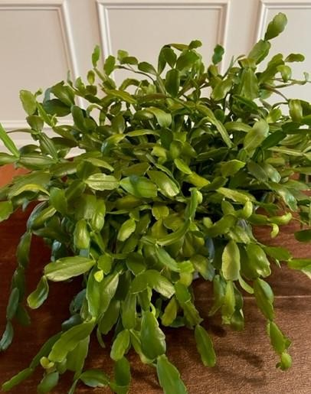

From Willi Webb Peace Lily | From Claudia Harris Mixed Succulent Planter
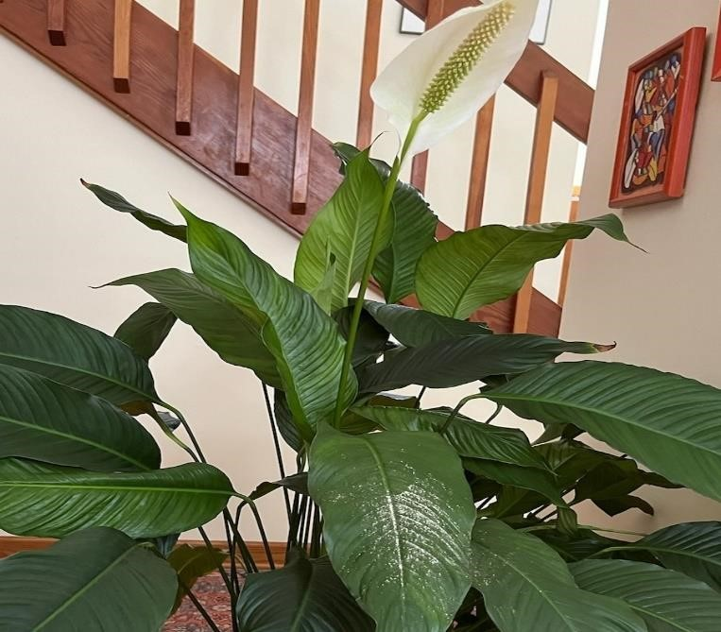 | 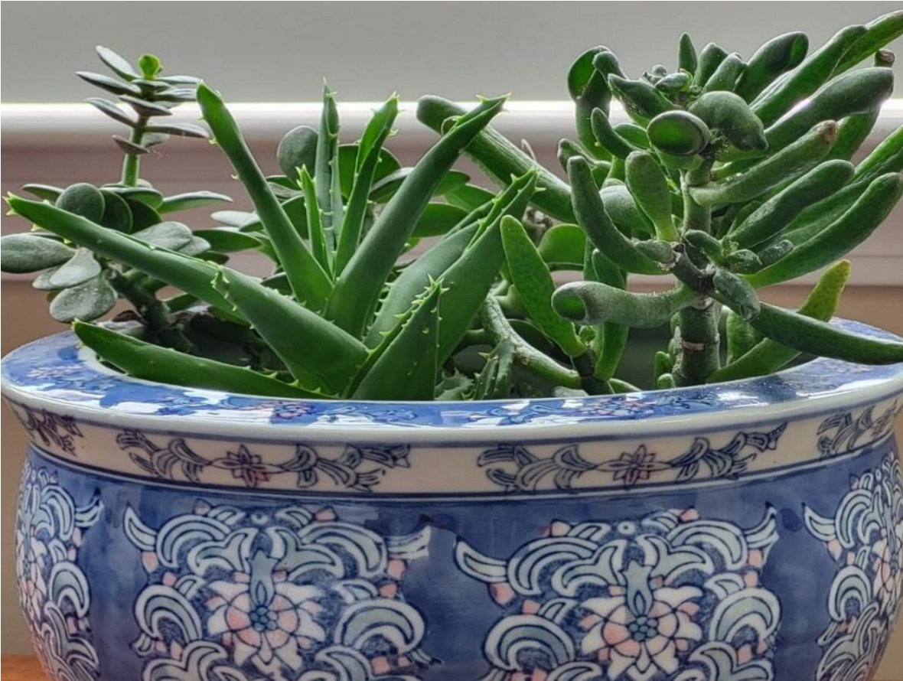

From Cordelia Blackwell Red Anthurium Plant | From Marjorie Younger  Spathiphyllum Peace Lily (19 years old)
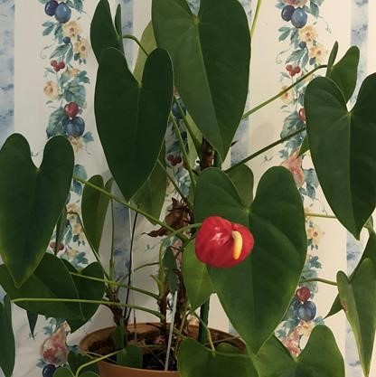 | 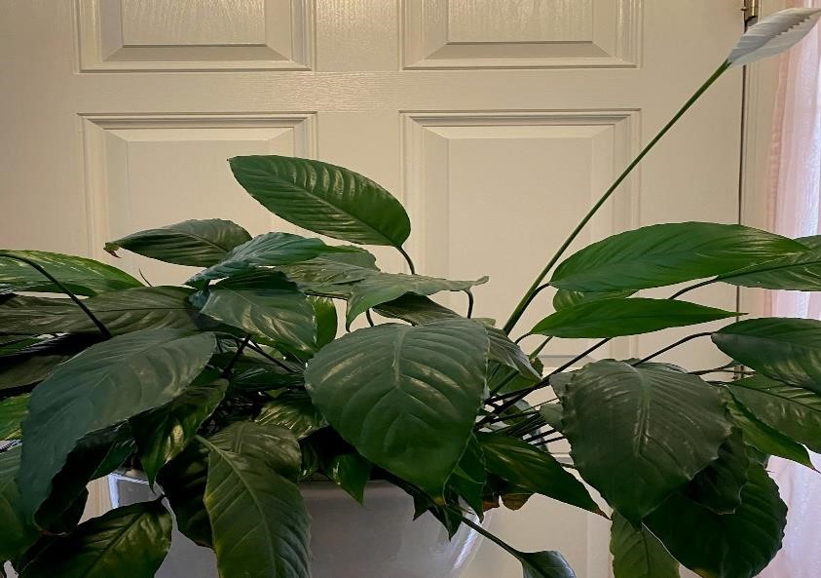

The Letter Below is from U.S. Congressman David Price Submitted by Pat Thoothman “For Your Information”
I am excited to share that the Honoring Our Promise to Address Comprehensive Toxics Act (Honoring Our PACT Act) passed the Senate and is headed to President Biden’s desk. This comprehensive bipartisan package is a historic and lifesaving victory for our veterans, addressing the potential toxic exposure they may have faced while in service and opens access to VA health care for those affected.

This has particular significance for North Carolina, where soldiers were exposed to contaminated water while stationed at Camp Lejeune. I am proud that this package includes legislation I coauthored, the Camp Lejeune Justice Act, which will provide service members and their families who suffered from exposure to contaminated water at Camp Lejeune in North Carolina the opportunity to seek judicial relief and have their long overdue day in court.

Following the tireless advocacy by veterans and their families, the Honoring Our PACT Act overcame the Senate Republican blockade and now heads to President Biden’s desk to become law. I firmly believe that the federal government has an obligation to care for our veterans, service members, and their families. Exposure to contaminated tap water and other toxins is a grave oversight, and those affected deserve justice. Our veterans and their families have waited decades for this opportunity and necessary care, and this legislation is a crucial step towards remedying long-term injustices. This is the most comprehensive legislation to date to treat toxic exposure as a cost of war, and I am proud to play a role in the authoring and passage of this legislation.

The bill text of the Honoring Our PACT Act can be found here. Information on the Camp Lejeune Justice Act can be found starting on page 76 of the Honoring Our PACT Act Rules text.

As always, please stay in touch with me on issues of concerns.
Sincerely,
David Price
U.S. Congressman

******************************************************************************************

The Heat is On 5 Hydrating Foods and Drinks for Summer
When the weather heats up in the summer, it is especially important to stay hydrated. Staying hydrated will give you energy in the heat, and keep your skin looking radiant and beautiful.

- Cucumbers: Cucumbers are made up of mostly water. But they also have a lot of other nutrients that will hydrate and nourish the body.

- Watermelon: Watermelon is one of the most hydrating foods out there. It has essential hydrating salts, calcium, magnesium, potassium and sodium. It is perfect for those hot summer days when you need to replenish your body.

- Coconut Water: It is one of the best ways to replace the water and electrolytes the body gives off in hot climates. It contains vitamins, minerals and electrolytes that perfectly replenish the body after a long day in the sun.

- Cabbage: Cabbage is known to lower cholesterol and it is packed with tons of vitamin C, making it an amazing beauty food. It also helps repair the body from the inside out. The best way to eat cabbage is raw, mixed in a green salad.

- Water with Lemon: The heat will cause us to sweat out even more water, so it is vital that we nourish the body with water. Adding lemon to water adds vitamin C and citric enzymes.
(5)
Cordelia Blackwell’s Interview with Claude Lee Continued from Page One

Cordelia: Tell us about your career and what are some of the positions you have held?
Claude: I relocated to Fort Lauderdale, Florida after graduation and taught Basic Math to high school seniors at Miami Carol City High School for several months; then I received a teaching position in Social Studies/CIVICS/8th grade at Crispus Attucks Middle School in Hollywood, Florida. I was also the Student Government Advisor. Relocated back to Raleigh, got married, taught 8th grade /CIVICS and was Social Studies Department Chair at JT Barber Middle School in New Bern, NC. I rented a room and traveled each weekend. I also taught Social Studies/8th Grade at Stafford Middle School in Hillsborough. Later in my career I became Assistant Dean of Student Services at Chapel Hill High School, At Risk Counselor at Hillside High School in Durham, Special Programs Counselor for 1st Generation Freshman at St.
Augustine’s University, Counselor at Creedmoor Elementary and Counselor and Assistant Dean of Student Services at Southeast Raleigh Magnet High School for 20 years. Retired after 33 years as an Educator.
Cordelia: Do you enjoy traveling and are there places you found interesting?
Claude: I thoroughly enjoy traveling. All the places that I have traveled have been interesting, Mt. Glacier in Montana, Hawaii, Bahamas, Mexico, Canada and China.
Cordelia: What is your favorite color, food, book, and movie?
Claude: My favorite color is blue. I really do not have a favorite food but my favorite meal of the day is breakfast (shrimp scampi and grits, fruit smoothies, salmon patties and omelets) I really do not have a favorite movie but I thoroughly enjoy movies based on a true story. I enjoy Christian, sci-fi, mystery, adventure and romance. My favorite book is the BIBLE and also inspirational books.
Cordelia: What are your hobbies and interesting things you like to do?
Claude: I thoroughly enjoy family time with my wife, daughter, son-in law, grandsons and games that we can all play. I also enjoy going to see a good movie with my wife or friends. Health/Wellness is very important for me, four day week Fitness workout. Prior to COVID, I thoroughly enjoyed the Men’s Prison (Yokefellow) Ministry at Wake Correction Facility, Women’s Prison Ministry, feeding the homeless, Ministry at City of Oaks/Elderly, Mentor for elementary boys with the WCPSS/Wake County Public School System.
Cordelia: Tell us something you would like us to know about you.
Claude: I am a Prostate Cancer survivor. My wife and I celebrated our 40th Anniversary on July 3rd with a two week vacation. I thoroughly enjoy spending time every weekend with my grandsons Caleb (5), Ezra (3) and Stephen is due September 8th. I am a proud PaPa.
**********************************************************************************************
From Gayle Gayton
Philippine Evergreen / from AARP Picnic 2021
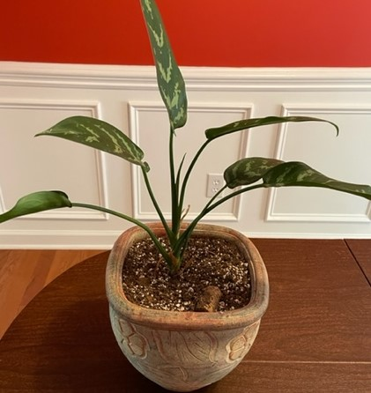

(6)

