THE CHRONICLE
RALEIGH-WAKE COUNTY CHAPTER #3689
http://AARPchapter3689.weebly.com
Kelly Vick – Editor
April 18, 2019

Speaker for Today  Michelle Michael  Ailey Young House  The oldest African American home in Wake Forest.  *****************************  Chapter Officers  Co-Presidents  Gayle Gayton  Willi Webb  Vice President  Cordelia Blackwell  Secretary  Wanda Richardson  Co-Treasurers  Geraldine Phillips  Marjorie Younger  *****************************  Committees  Community Services (Oweida Cole)  Fundraising (Lorrie Berlenbach)  Historian (Thelma Blake)  Legislative (Karen Clark)  Membership (Karen Youmans)  Nominating (Allan Younger)  Program (Allan Younger)  Sunshine (Pat Toothman)  The Chronicle (Kelly Vick)  Telephone (Beverly Clark)  Webmaster (Claudia Harris) |  |  | MESSAGE FROM OUR PRESIDENT  AZALEA GARDENS:  This is a must go, must see 1.5 acres of garden area with over 60 varieties of deciduous native and Encore Azaleas, located on the grounds of WRAL-TV at 2619 Western Boulevard, Raleigh, NC 27606.  If you have never been to the Azalea Gardens, the best time to enjoy its splendor of color is spring and fall. The Azalea symbolizes love, moderation and temperance.  The gardens are open year round, dawn to dusk, open to the public free of charge with free parking.  Looking for a great place to take photographs? This is it! A perfect place for taking photographs of weddings, graduations, family reunions and baptisms. How about your next group outing? Or just a quiet get away with a book? Reservations are not required, but be mindful the gardens are public, be respectful of each other.  While enjoying the vast array of plants you may opt to bring your picnic lunch. There are several benches, open grassy areas and the restrooms are open dawn to dusk.  NO GRILLING, NO ALCOHOLIC BEVERAGES, NO SMOKING, NO PETS. Remember this is a carry in, carry out garden.  It is amazing to be surrounded by so many plants, so many colors, so peaceful you nearly forget you are in the city. Do enjoy!  Gayle Gayton  SPECIAL ANNOUNCEMENT  Shredding Event - Saturday, April 27, 2019  Location: Coastal Credit Union  1000 Saint Albans Drive, Raleigh, NC 27609  Time: 8:00 am - 11:30 am or until trucks are full
 | COMMITTEE REPORTS
COMMUNITY SERVICE  The month of April certainly brought showers of blessings to several of our community service recipients. We delivered checks of over $100 each to The Shepherds Table Soup Kitchen, Urban Ministries and Healing Transitions, respectively. Needless to say, all the organizations were indeed grateful for our generosity. These donations are results of your generous contributions for the last three months, and we are so very grateful and thankful for all your donations.  On April 2nd, Oweida Cole was invited to and attended a “Lifting Minds and Hearts” breakfast at Edenton Street United Methodist Church, which was sponsored by Loaves and Fishes. It was indeed an interesting experience that included a guest speaker as well as performances by students from Loaves and Fishes. I have a copy of the program in case you are interested.  The week of April 8th –12th, was designated as “Volunteer Appreciation Week”. On Monday, April 8th, we received an appreciation card from Urban Ministries. Coincidentally, on that day, seven Chapter members (Cathy Little, Gayle and Edmond Gayton, Claude Lee, James Nelson, Geri Phillips, and Oweida Cole) were on hand to serve guests who came to shop in the Food Pantry. We had a great time assisting guests as well as cultivating and building relationships. See picture below:  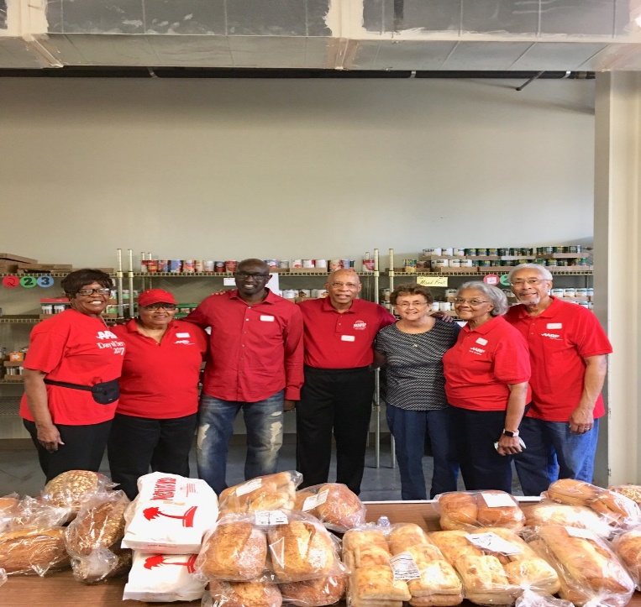  We will be volunteering at the Food Pantry again the second Monday in May and each month thereafter. In fact, you are welcome to volunteer today for any month for the rest of the year. I have a volunteer sheet available and we will need at least four members each month.  Our community service project for April is Loaves and Fishes. For May is the Helen Wright Center for Women. |  |  |  |  | TELEPHONE  Please return phone calls by the Saturday morning after the call as to whether you will be attending the meeting and eating lunch. If you do not return the call, we will not count you for lunch. The purpose of the Telephone Committee is to get a count for lunch to Atria’s staff that Sunday afternoon before the next meeting. If you need to cancel your lunch, please call your caller by the Saturday morning before the Thursday meeting, because if you sign-up to eat lunch and do not come to the meeting, our chapter will have to pay for your lunch.  FUNDRAISING  Mother's Day Extravaganza is May 11, 2019, 2:00 – 5:00 p.m., Marriott Courtyard Brier Creek, 10600 Little Brier Creek Lane, Raleigh, NC 27617. If you cannot attend, please consider a sponsorship. Forms are available from Marilyn Pearson or Lorie Berlenbach.  NOMINATING  We have one vacancy for a Co-Secretary. This person will be working in partnership with another co-secretary, and responsible for recording minutes of our chapter and board meetings.  MEMBERSHIP  We are asking all chapter members to arrive for the monthly meeting at 10:45 a.m. to be ready for the 11:00 meeting. If you invite a guest, please ask your guest to arrive at 10:30 a.m. to register at the membership table.  http://AARPchapter3689.weebly.com is our website address. You will need a password when you access the "Members Only" section. Contact Claudia Harris (919-435-0861) if you do not have the password and if you have changes to the information listed in the directory.  SUNSHINE  There are several members who are having health issues and cannot come to the meetings. We have been calling them, sending cards and e-mails. If you know of anyone who is ill or a bereaved family, feel free to call, e-mail them or send your own card or call Pat Toothman (919-846-8477) or e-mail her at pattoothman@hotmail.com.  We have a basket filled with gifts for birthday members to choose one gift. Anyone who misses their birthday month can get a gift from the basket when they return.  APRIL BIRTHDAYS  Willi Webb (3) Louise Halpern (8) Joanne Fluke (11) Kelly Vick (13) Cathy Little (16) Oweida Cole (19) Alan Talley (26)

