THE CHRONICLE
RALEIGH-WAKE COUNTY CHAPTER #3689
http://AARPchapter3689.weebly.com
Kelly Vick – Editor
January – February 2021

Speaker for Today  Professor Flora Wadelington N.C. A&T State University  “Historical Black Colleges  and Universities”  *********  The Speaker in March  Anne Jenkins  Co-Chair, Forsyth AARP Chapter #1797  **********************  Chapter Officers  Co-Presidents  Gayle Gayton  Willi Webb  Vice President  Cordelia Blackwell  Secretary  Gwenn Weaver  Co-Treasurers  Cynthia Bradley  Claudia Harris  *****************************  Committees  Community Service (Oweida Cole)  Fundraising (Lorrie Berlenbach)  Legislative (Karen Clark)  Membership (Karen Youmans)  Nominating (Allan Younger)  Program (Allan Younger)  Sunshine (Claude Lee)  Telephone (Pat Toothman)  Staff Coordinates  Ambassador (James Hines)  Historian (Thelma Blake)  Newsletter (Kelly Vick)  Reflections (Grace Krishnamurty)  Webmaster (Claudia Harris) |  | MESSAGE FROM OUR CO-PRESIDENTS  Gayle Gayton and Willi Webb  ONE MORE YEAR  Our last AARP Chapter #3689 in-person meeting was held on Thursday, February 20, 2020 at our regular meeting site, Atria Oakridge on Durant Road. On the same day, Wake County School System announced that due to an impending snow storm, schools would close early. We were also getting ready for primary voting.  On March 9, 2020, we received an e-mail from Joyce Wright, the Executive Director of Atria Oakridge, advising that due to a virus they would no longer allow more than three people from outside the residence to gather in the building. The chapter started postponing fundraisers and chapter meetings. Covid information became plentiful.  Little did we know that the virus called Covid-19 or Coronavirus would become a world-wide pandemic. As of now, the pandemic has claimed the lives of over four million people.  One year later, we are still restricted from large group gatherings and restaurants. Schools and businesses are closed and in some cases, businesses have gone out of business. Many of us have missed holiday gatherings, graduations and vacations. All in the name of Covid-19.  Covid testing was ramped up, then came the vaccine. The first Covid-19 vaccination was given in New York City on Monday, December 14, 2020. In the last weeks, we have been advised that at least two variants are now in several states. For more testing/vaccine info, go to yourshotyourspot.nc.gov.  Chapter #3689 has continued to persevere, be creative in finding new and interesting ways to keep our meetings interesting to our members. Overall attendance has been down, but encouraging. This year, we hope to reach out to other chapters and the community to share in our meetings.  It has been a challenge. We thank you for your support as we continue our virtual meetings. Please take advantage of the many North Carolina AARP state volunteer initiatives that have come out, with more to come.  For more AARP North Carolina news, get to know us at aarp.org/nc.  In the meantime...WASH YOUR HANDS, WEAR A MASK, MAINTAIN SIX FEET DISTANCE and stay safe.
COMMITTEE REPORTS
SUNSHINE
Birthday e-cards were sent to our members listed below who have birthdays in January and February. If you know of anyone who is ill or a bereaved family, please call Claude Lee (919-971-3317) or e-mail him at claudealeejr@gmail.com.
JANUARY BIRTHDAYS | FEBRUARY BIRTHDAYS
Stewart Vick (4)  Tony Gandy (11)  Edmond Gayton (20)  Felex Gathings (25)  Pearl McCollum (25) | Betty Franks (2)  Gayle Gayton (12)  Leon Cooke (23)  Kenneth Clark (28)

MEMBERSHIP – If you have not renewed your membership for 2021, please read the information below:
Our chapter membership dues have been changed to $10.00 per year. We are in the process of updating our 2021 membership directory. You must be a member of the National AARP and you will need your national membership card to complete the membership form. The membership form is on our website with instructions on where to mail it.

In order for the Membership Committee to keep accurate count of our members for our Zoom monthly meetings, please add your name to your Zoom video conference page or when you dial in with your telephone.

NOMINATING
We have two vacancies: (1) Co-Secretary – will be working in partnership with another Co-Secretary. This position is responsible for recording minutes of our chapter and board meetings. (2) Co-Legislative – will be working in partnership with another Legislative representative to maintain a close working relationship with the State Office to ensure that the chapter focuses on state and national priorities for seniors.

TELEPHONE
The Telephone Committee continues to keep in touch with members via e-mail and telephone calls. It is a way to keep members informed and receive any suggestions they may have. Help us keep Chapter #3689 active.

COMMUNITY SERVICE
February..... "Love Month" and we are pleased to again announce that the Community Service Committee is still trying to spread the "love". We would like to thank our chapter members for their outstanding contribution to the Clothing Drive in January. More than 21 members contributed items such as coats, sweaters, shoes, suits, gloves and hats that were delivered the same day to the Women's and Men's Shelter. The men at Healing Transitions were very elated and more than grateful as they unloaded the items of clothing from the car.

Earlier this month, Helping Hands Mission also requested coats and blankets and we were able to gift them with several leather coats as well as a huge bag of clothing and numerous sweaters.

Just a reminder that in spite of the pandemic, we still volunteer at the Urban Ministries Food Pantry at least once and sometimes twice per month. Actually, this is the third year that we have been continuously volunteering at this facility.

(2)

FEBRUARY IS
BLACK HISTORY MONTH
Recognizing one of our Faithful Members “James M. Hines”

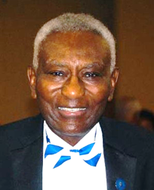

James M. Hines has been a member of our Chapter since 2003 and serves as our Ambassador. He has volunteered countless hours singing ballads and love songs in senior facilities throughout North Carolina and Virginia. James is a native of Greenville, North Carolina and a graduate of North Carolina A&T State University School of Engineering. He is a member of the Phi Beta Sigma Fraternity; served as Captain in the U.S. Army Signal Corps; participated in the 1960 Greensboro sit ins at the Woolworth store (now the International Civil Rights Center and Museum); first black engineer employed at the Union Carbide plant in North Carolina; worked with the Eastman Kodak Corporation in Rochester, NY; owned a restaurant in Rochester NY, introducing diners to NC ‘s barbeque; owned and operated a minority construction company in Waverly, NY; joined the IBM Corporation in Endicott, NY, eventually retiring in VA; first president of Phi Beta Sigma Credit Union in Washington, DC. Served on Governor Doug Wilder’s election committee; Manassas Historical Society; a gold medal vocalist winner in Wake County 2008 Senior Games; patient advocate for AMS medical products for cancer treatment. In 2019 James was honored to receive the Living Legend Award from the Omega Phi Psi Fraternity, Inc., and the Triangle Uplift Foundation. James is loved by people in his community and within his different organizations. He has spent his life helping others and continues to share his passion for community service. He has been our entertainer for our Chapter’s special occasions. James, we want you to know that we love you, and you are a great asset to this Chapter.

AGEING ATTITUDES QUIZ – Take the Ageing Attitudes Quiz as a first step in your Stand Against Ageism. Check your attitudes against these commonly held views of ageing and older persons and find out. This quiz will be a part of the ageism program on March 18, 2021. The program will be presented by Co-Chair Anne Jenkins of Forsyth AARP Chapter #1797. Please review and have with you at our March meeting. Anne will review.

1 “All older people are the same.”
- True

- False

2 “Poor heath is inevitable in older age.”
- True

- False

3 “An older person is somebody aged 60 years and above.”
- True

- False

4 “My attitude to ageing has little or no influence on my health.”
- True

- False

5 “Ageing is an obstacle to a good life and must be overcome.”
- True

- False

6 “Older adults are a drain on the economy, including health systems.”
- True

- False

7 “Ageism means having negative attitudes and or discriminating against people because of their age.”
- True

- False

8 “I can be ageist and not know it.”
- True

- False

9 "We can combat ageism!"
- True

- False

IMPORTANT INFORMATION TO READ

UPCOMING AARP EVENTS FOR BLACK HISTORY MONTH IN NORTH CAROLINA:

Monday, Feb. 22 at 1:30 pm ET: Reflections Past and Actions Present in Geer Cemetery
Capacity: 50; Register: https://www.cvent.com/events/black-history-month-event-reflections-past-and-actions-present-in-geer-cemetery/event-summary-32c64a075b64444091dd050db6d1e0d4.aspx

Tuesday, Feb. 23 at 4:00 pm ET: International Civil Rights Museum Virtual Tour - Capacity: 100
Register: https://www.cvent.com/events/aarp-nc-triad-presents-international-civil-rights-museum-virtual-tour-black-history-month-event-4-pm/event-summary-b709e1f096a54c1cacf4aefa8008f9e1.aspx

Wednesday, Feb. 25 at 12:00 pm ET: Actively Aging Activism and Art: Ann Woodford- Register: https://www.cvent.com/events/black-history-month-event-actively-aging-activism-and-art-ann-woodford-2-25-2021-/event-summary-f570876f976541e2929710292c5b82b1.aspx

******************************************************************************************

Your 2021 Guide to Food Freebies all Year (Sisters from AARP):
Tacos, Chinese food and chocolate cake are even tastier when on the house. Mark your calendar with these food holidays and know where to look for free and cheap eats all year. Copy the following website and paste it into your browser https://www.sistersletter.com/work-money/your-2021-guide-to-food-freebies to see where all the Food Freebies are located.

******************************************************************************************

Ten Things You Need to Know About Your 2020 Tax Return:
Filing taxes will not be the same this year - by John Waggoner, AARP updated January 27, 2021. Copy the following website and paste it into your browser to read his report What Seniors Should Know Before Filing 2020 Taxes (aarp.org).

******************************************************************************************

CONGRATULATIONS!!!
Congratulations to Oweida Cole and George Gross for winning the best Christmas outfits at our Chapter December 2020 meeting (it was a tie). Chapter members voted on the Zoom voting tab. Oweida had on a beautiful Christmas sweater with Christmas lays around her neck and a flashing headband with different color lights. George was wrapped up as a Christmas present with a large bow wrapped around him. We had a Christmas / Zoom fun time at our last meeting of the year.

(5)

2019 Holiday Gift Exchange
(Written by Kelly Vick)

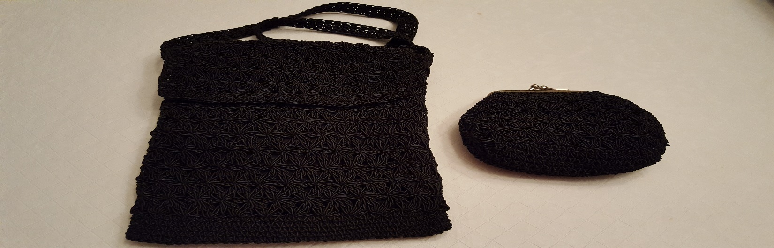

I am very excited to write this short statement about the above black crochet shoulder bag and change purse to match. I received this gift at “Chapter #3689 - 2019 Holiday Gift Exchange”. I was one of the last persons to choose a gift. Karen Youmans and I were working at the Membership table and we did not receive a number to choose a gift; so we were one of the last to choose a gift. When I opened this gift, it brought a smile to my face (what a nice shoulder bag set). Whoever brought this gift to the gift exchange, I want to thank you. I do a lot of walking during this pandemic. Last spring and summer I used this shoulder bag each time I walked. This bag is the right size for my keys, cell phone, face mask and a pair of gloves. What a lovely gift. I think this gift was left for me to choose. Holiday Gift Exchange was always exciting for our Chapter. We have to be patient. This pandemic will end and we will be able to do some of the special events and projects we have done in the past.

If you have great ideas that you think of interest to our members, please e-mail them to Kelly Vick and your point of interest will be listed in The Chronicle (sandkvick@nc.rr.com).
SOME EXAMPLES
Favorite Recipe
Funny Story
Statement about something special and exciting that happened to you.

(6)

