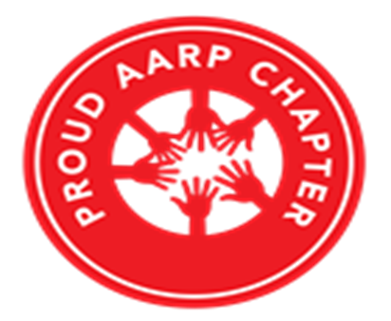 |  | THE CHRONICLE  RALEIGH-WAKE COUNTY CHAPTER #3689  http://AARPchapter3689.weebly.com  Kelly Vick – Editor  July – August 2021
Speaker for Today  Jeanne and Scott Van Divender “Fraud in 2021”  **********************  Chapter Officers  Co-Presidents  Gayle Gayton  Willi Webb  Vice President  Cordelia Blackwell  Secretary  Gwenn Weaver  Co-Treasurers  Cynthia Bradley  Claudia Harris  *****************************  Committees  Community Service (Oweida Cole)  Fundraising (Lorrie Berlenbach)  Legislative (Karen Clark)  Membership (Karen Youmans)  Nominating (Allan Younger)  Program (Allan Younger)  Sunshine (Claude Lee)  Telephone (Pat Toothman)  Staff Coordinates  Ambassador (James Hines)  Historian (Thelma Blake)  Newsletter (Kelly Vick)  Reflections (Grace Krishnamurty)  Webmaster (Claudia Harris) |  | MESSAGE FROM OUR CO-PRESIDENTS  Gayle Gayton and Willi Webb  The importance of saying “I love You” during COVID-19  1- Saying “I love you” increases the immune system:  - Recent studies have shown that those who often say "I love you" have higher immunity than those who do not express their feelings. Love and affection, like all positive emotions, activate the immune system.  - Protect yourself from the severity of the virus!  - Say “I love you” whenever you speak to someone who has a place in your heart. It has the same effect in person as it does over the phone.  2 - Recreate a sense of security despite the uncertainty:  - Since we have no control over the situation, we all need reassuring benchmarks more than ever.  - Saying “I love you” elicits a response.  - A response that is good for the soul that comforts us and brings us to the safe field of our long-term relationships.  3 - Create a relaxed atmosphere during quarantine:  Imagine the effect you will produce when you say with intensity and without special reason, “I love you too”:  - your spouse roaming like a caged lion  - to your child who grumbles because they can’t go out  - to your sibling who complains all the time  Do you see their smile and their change of state when doing so? It’s enough to find harmony that has been put to the test by all the constraints that we must impose on ourselves.
COMMITTEE REPORTS
SUNSHINE
Birthday cards were sent to our members listed below who have birthdays in July and August. If you know of anyone who is ill or a bereaved family, please call Claude Lee (919-971-3317) or e-mail him at claudealeejr@gmail.com.

Our sympathies go out to Lillian Walsh’s family. Lillian was a former member of our Chapter. She passed away at the age of 91 on July 29th after a long battle with dementia and cancer.
JULY | BIRTHDAYS | AUGUST | BIRTHDAYS
Gwenn Weaver (10)  Marjorie Younger (19) | Neal Franks (24)  Mary Madlon (31) | Pauline Luton (2)  James Hines (5)  James Nelson, Jr. (6) | Hew Dorssett (11)  Fannie Sedita (16)  John Speights (25)

COMMUNITY SERVICE
"Do your little bit of good where you are, it's those little bits of good put together that overwhelms the world".

The volunteer contributions that we report periodically means more to this committee than you can imagine. It's not just so that we have something to report to the Chronicle.

Please be aware of these happenings:

1) Numerous trips were made to the Women's Center within the last month to deliver bags of clothing, food items, toiletries and a vast amount of powdered milk that was donated by Claudia. You can't imagine how much they appreciated these items, especially all the milk. In addition, contact Oweida Cole if you have T-Shirts, jeans, pillows, blankets, sleeping bags, Pop Tarts, soups, Ravioli, chili, etc.; however no fruits or vegetables.

2) In lieu of school supplies, Fox Road Elementary Schools 5th grade students (80) and four teachers request the following:

4 boxes spaghetti  8 bags small white marshmallows  8 bags red cups - 8 oz.  4 bottles hydrogen peroxide  4 btls Dawn dish soap - sml btl. - 7 oz.  4 boxes food coloring  8 - 3 packs of active dry yeast | 200 straws - straight/non flexible  8 bags cotton balls  4 boxes alka seltzer - generic brand  8 gallons of vegetable oil  8 gallons Karo syrup  12 tubes of mentos  20 boxes Hot Tamales (candy) | 4 rolls heavy duty foil - 75 foot  4 bags s'mores marshmallows -large - white ones  200 quart size zip lock bags  100 mini Hershey bars  4 packages of sprinkles  400 white mint life savers

Perhaps we can make some decisions as to who would like to donate a specific item or items and let me know. Then we will decide a time in which to meet at Kohl’s so as I may collect the items (hopefully by the end of the first week in September) and then set another date if the need arises.

3) Wake Up and Read (WUAR) needs volunteers, however, these positions are available for Volunteers with previous experience. Nevertheless, they do accept new and used children's books.

"No act of kindness, no matter how small, is ever wasted." AESOP

(2)

COMMITTEE REPORTS – (continued)

NOMINATING
We have two vacancies: (1) Co-Secretary – will be working in partnership with another Co-Secretary. This position is responsible for recording minutes of our chapter and board meetings. (2) Co-Legislative – will be working in partnership with another Legislative representative to maintain a close working relationship with the State Office to ensure that the chapter focuses on state and national priorities for seniors.

TELEPHONE
The Telephone Committee continues to keep in touch with members via e-mail and telephone calls. It is a way to keep members informed and receive any suggestions they may have. Help us keep Chapter #3689 active.

MEMBERSHIP
Our chapter membership dues have been changed to $10.00 per year. You must be a member of the National AARP and you will need your national membership card to complete the membership form. The membership form is on our website with instructions on where to mail it.

In order for the Membership Committee to keep accurate count of our members for our Zoom monthly meetings, please add your name to your Zoom video conference page or when you dial in with your telephone.

******************************************************************************************************

“THE VIEW” CO-HOSTS’ SUMMER 2021 READING LIST: (Submitted by Gayle Gayton)

“Summer on the Bluffs” by Sunny Hostin — Sunny Hostin’s book pic
Taking place on the island of Martha’s Vineyard. The book tells the story of three 20-something women’s relationship with their godmother, Amelia Vaux Tanner. Over the summer, she reveals to her goddaughters how and why she came into their lives. The three women from all different backgrounds spend one last golden summer together with their godmother before moving to the south of France to reunite with her college sweetheart. Sometimes secrets bring people together or tear them apart, but you’ll have to read the novel to find out which one happens!

“Anansi Boys” by Neil Gaiman— Whoopi Goldberg’s book pic
“Fat Charlie”, as his father called him, thought there was nothing wrong with his so-called “normal” life until his father dropped dead on a Florida karaoke stage. Charlie didn’t know the secrets his dad was keeping, including a brother, who showed up at his doorstep one night. The brother he never knew makes “Fat Charlie’s” life more interesting, and a lot more dangerous.

“The Invisible String” by Patrice Karst— book Sara Haines reads to her children
In this children’s book, twins Jeremy and Liza learn from their mother that we’re all connected by an invisible string made of love. The string is the tie that binds us together and it reaches all over the world. The story uses a simple approach to teach a lesson about love and overcoming loneliness and separation. No matter where we go, we’re never really alone, because love is always connecting us through the invisible string.

Israel: A Simple Guide to the Most Misunderstood Country on Earth” by Noa Tishby—Meghan McCain’ book pic
Noa Tishby is an Israeli-American who wrote this book to help people understand the history of Israel and Zionism. It has a strong autobiographical narrative as she integrates her personal and multi-generational family story with the history and development of Israel beginning in biblical times, to WWII, to the modern Israel-Palestinian conflict.

(3)

A Silver Lining Story
From One Of Our Members
Mary Madlon
(Joined this Chapter in 2014 and Co-President for the Years 2017 & 2018)

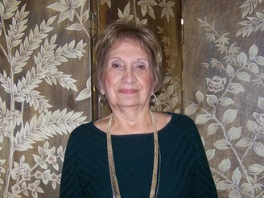

A Little Normalcy to My Life
I hope everyone is enjoying the return of a little normalcy to our lives. I do miss seeing all of you. It’s been difficult to join the meetings on Thursdays. I either have a doctor’s appointment or my caregiver and friend (June) has arrived to prepare my lunch. Unfortunately, I was back in the hospital at the end of June because I was having more mini strokes. They adjusted my medications and placed a loop in my chest to monitor my heart. I am feeling much better and thank you for your many cards.

I hope everyone in our chapter is vaccinated and have not lost anyone to Covid. I lost my first cousin to Covid. I felt terrible since her children went to Itlay and even though they were there for three weeks, they never got to see her.

I am happy to share some great experiences I had in 2020. My granddaughter, Christine, who lives in San Antonio, Texas called to tell me she would be homeschooling her two girls, Eleanor (4) and Penny (7) and wanted to know if I would be willing to teach them art. I was thrilled since I would get to face-time the girls every week. I made sure the girls had the same supplies as I did, through Amazon. I also got to meet their little brother Ben when he would wake from his afternoon nap. It was very rewarding for me to watch the girls grow artistically and be able to succeed in a variety of art media, paint, chalk, markers, colored pencils and colored paper.

I was also blessed last year with the birth of three more great granddaughters, Haley, who joined older brother Kyle and Raelynn who was a first born. These two great granddaughters live near Dallas, Texas. Another great granddaughter, Felicity, joined sister, Josie Mae, here in Raleigh. I am now awaiting the birth of my ninth great granddaughter, Mollie Jane who will join older sisters, Mary Claire and Joy and older brother Jack, in early September. I feel very lucky to be able to see and enjoy almost a dozen great grandchildren. Only two of my children have grandchildren; Angela the oldest daughter, who lives near San Antonio, Texas, and Jim, my oldest son who lives in Raleigh, N.C.

As we face another Covid Variant, I hope that all our members are vaccinated and even though it is difficult, please wear a mask.

(4)

Pictures You Can Remember From The Past: (Submitted by Gayle Gayton)

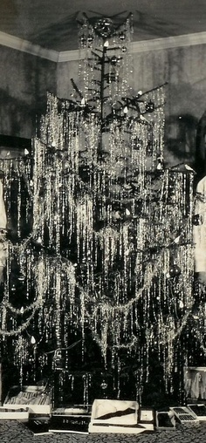 | 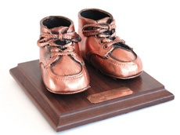
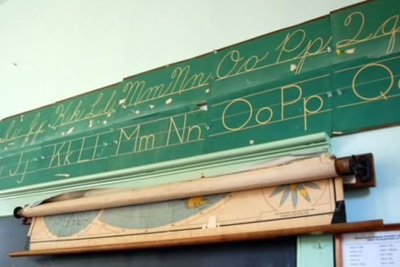 | 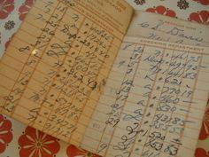
 | 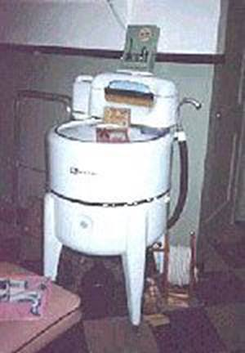 |  | 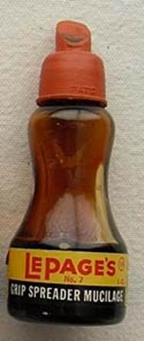

(5)

Staying Active as You Age Will Help Reduce Falls and Injuries
https://vivaprime.com/balance-exercises-for-seniors/
As people age, it’s nearly inevitable that they will begin to experience mobility issues. It becomes more difficult to get in and out of the shower, bend over to pick up something off the floor, or climb up and down the stairs. These are all activities that can lead to falls and serious injuries. However, if you improve your balance with proper exercises then you can prevent falls, injury, and continue to live life on your own terms. In this article, we will be looking at balance exercises for seniors.

Balance Exercises:
When people think of balance exercises, they usually picture people doing handstands and difficult yoga poses. Yet, balance exercises can be very simple and easy to do, and get progressively harder as you go, if you choose to try more strenuous activities. Balance exercises are defined as a form of training that strengthens the muscles that are responsible for keeping the body upright. These muscle groups are mostly the core and legs. It is very important to do them because they can help to prevent falls. A study published in Science Direct titled Balance in the Elderly found that - Balance disorders manifest in poor performances in standing, leaning, stepping, walking, responding to an external perturbation and tasks of mobility and transfer. There is good evidence that appropriate exercise can improve balance and reduce falls in older people. Balancing exercises also help keep the joints in the body lubricated by warming up the synovial fluid. Keeping joints active and lubricated can help prevent injuries when you are doing your day-to-day activities. By participating in balance exercises, you can help significantly reduce your chances of falling and suffering serious injuries. There are a lot of different exercises that you can do to improve your balance, too.

Below are Easy Balance Exercises for Seniors:
There are many exercises that you can do to help improve your balance and coordination, but you want to make sure you’re doing exercises that are appropriate for your body and your needs, and that you’re doing them properly, too. Some precautions you should take when doing balancing exercises is to make sure that there are no sharp objects lying around. If you are not using objects like a table or chair for assistance, you should make sure that they are a safe distance away from you. The floor should also be clear of anything you could trip on. With that said, let’s take a look at the different types of balance exercises for seniors that you can do at home.

Standing on One Foot
This is one of the easiest balance exercises to do at home. Put your weight on one leg and then slowly lift the other off the ground, to the side, or to the front. If you need to, you can do this by standing by a chair or counter and use your hand to help you with balancing. Try to keep your balance for 30 seconds to one minute. This exercise helps to build core and leg muscle while making your brain more active when trying to balance.

Tightrope Walk
To do this exercise, walk like you would if you were on a tightrope. Put your heel right in front of your toes and then step your other foot around and do the same thing. Try to walk 20 feet and then turn around and walk back. If you feel like you are going to lose your balance, simply step out of the walk and then start again where you left off. This exercise helps to activate your brain to be more reactive when you start to lose your balance so that you do not fall.

Getting Into and Out of a Chair
Grab a sturdy chair for this exercise and move it away from other furniture. The goal is to be able to sit down and then get out of the chair without using arm rests or the table to help you get up. You can do this by using your hands on your knees to get up. If you do need to use something else to help you get in and out of the chair you can, however, activate your legs and core and try to mostly use these body parts. Get into and out of the chair ten times. This exercise strengthens your core muscles and leg muscles which keep you on your feet.

Standing on Your Tiptoes
You can use the back of a chair to help with this exercise. Stand behind the chair and then slowly rise onto the tips of your toes. Hold here for ten seconds and then lower back down onto your heels. Do this ten times. This exercise will help to strengthen your calves and ankles.

Eagle Pose
Another great way to practice your balance is by doing the yoga pose called Eagle Pose. To do this you balance on one foot while wrapping the other leg around the one you are balancing on. The easier version and best for beginners is to balance on one foot and then cross your other foot over the ankle or thigh. Do not let it touch the ground. You can also cross your arms and have your hands touch your shoulders like you are giving yourself a hug. This pose is great not only for balance but for strengthening your calves and ankles and is great for sciatica and lower back pain.

Final Notes
These five options are great beginner balance exercises for seniors. Practicing them even a couple days a week is a great way to start getting active and incorporating them into your routine.

(6)

FREE ONLINE COLLEGE COURSES FOR SENIORS – glendid.com
As we age, our challenges and purpose change. Many seniors face cognitive and physical decline if they don’t treat themselves properly. Lifelong learning is important for seniors: It makes them healthier, happier and way more interested in the world around them. Many schools and courses see opportunity in the group “seniors” and offer special courses. Seniors are now able to join online classes and even follow courses for free! Find more information below:

Can Seniors Go to College for Free?
Yes, it is possible for seniors to attend college for free. In fact, schools in all 50 states offer discounted or free online college courses for seniors. To qualify, individuals typically must possess U.S. citizenship and meet certain age requirements. Some colleges may consider individuals as young as 55 as seniors, while others consider individuals older than 60 as senior citizens. Some colleges only offer free courses to seniors for non-degree credit. Other schools may only let seniors enroll in free courses after paying students complete enrollment. Therefore, some popular courses may fill too quickly for free enrollment candidates.

The Benefits of Returning to College as a Senior:
If you have asked yourself, while considered college at 50, “Am I too old?” don’t worry – you’re not. The AARP might be knocking at the door, but there are plenty of good reasons to go back to school to enhance the last years of your career, get a whole new degree, or just explore your options.

An Active Mind Has Health Benefits:
As we get older, our physical bodies aren’t the only things that decline. Unfortunately, our minds can deteriorate as well. When this happens, the memory may suffer, and we may lose some of the clarity we had as younger people. The good news is that there are things you can do to keep your mind sharp, and going back to school would definitely qualify as one of them! Whether you choose to take a single course or pursue a degree, your studies will help keep your brain healthy. Continuing education may even help you prevent serious diseases that affect older adults such as Alzheimer’s and dementia, for example. These are very compelling reasons to hit the books, even if you have to grab your reading glasses to do so!

Increase Social Interaction:
Social Researchers through comprehensive national studies have discovered just how important it is for people to avoid isolation. Human beings are social animals. When not experiencing social interaction, people tend to fall into a depression. This is especially true when workers retire, a move that deletes the socials aspects brought about by one’s employment. As people age, they tend to withdraw and become lonelier. Combating loneliness is one of the best motivations to return to college. Even if you’re not thinking about new career choices over 50, consider the fun classes for seniors, offers from universities for senior citizens.

**************************************************************************************************

If you have a story or great ideas that you think of interest to our members, please e-mail them to Kelly Vick and your point of interest will be listed in The Chronicle (sandkvick@nc.rr.com).
SOME EXAMPLES
Silver Lining Story
Favorite Recipe
Statement about something special and exciting that happened to you.

