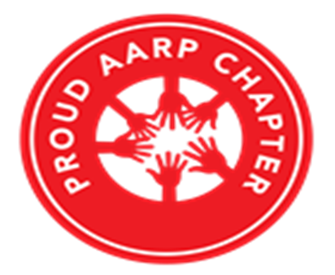 |  | THE CHRONICLE  RALEIGH-WAKE COUNTY CHAPTER #3689  http://AARPchapter3689.weebly.com  Kelly Vick – Editor  March – April 2021
Speaker for Today  Dr. Brittany Baker  School of Nursing  North Carolina  Central University  “Current Status of COVID-19"  ***********************  Chapter Officers  Co-Presidents  Gayle Gayton  Willi Webb  Vice President  Cordelia Blackwell  Secretary  Gwenn Weaver  Co-Treasurers  Cynthia Bradley  Claudia Harris  ***************************  Committees  Community Service (Oweida Cole)  Fundraising (Lorrie Berlenbach)  Legislative (Karen Clark)  Membership (Karen Youmans)  Nominating (Allan Younger)  Program (Allan Younger)  Sunshine (Claude Lee)  Telephone (Pat Toothman)  Staff Coordinates  Ambassador (James Hines)  Historian (Thelma Blake)  Newsletter (Kelly Vick)  Reflections (Grace Krishnamurty)  Webmaster (Claudia Harris) |  |  | _______________________________________________  MESSAGE FROM OUR CO-PRESIDENTS  Gayle Gayton and Willi Webb  SHARING  AARP divides the country into six regions.  Staff and volunteer leaders at regional, state and community help co-ordinate the efforts in each of our initiatives and programs.  The regions are West, Central, South, East Coast, large and Mega. North Carolina, based on population, is part of the Large Region.  Once a month chapter leaders are involved in a Large Region call in. A few of the Large Region states are: Arizona, Georgia, Michigan, New Jersey and Tennessee. The Large Region coordinators share information to help local leaders support and encourage their local chapters.  Sharing...from the March call in:  March was Women’s History Month. Their theme was “Choose to Challenge”.  They suggested sending a card to a woman that inspires you, share a book about a famous woman. One of the leaders suggested reading the poem “I am a Woman, Hear Me Roar.”  Here are some suggestions they had to keep our chapter engaged:  Make monthly calls to members, hold Zoom Meetings, prepare an agenda, share state and local health information/news, recognize birthdays, follow up to those not attending virtual meetings. Their newest suggestion is to send a personal note. Do all or some of these points sound familiar? Do they sound like ideas we are already implementing?  Sharing a few more ideas... National Friendly Calls, weekly or monthly 888-281-0145.  “Power of the Pen”:  Decorate a craft card and share with nursing home residents or veterans. More information on this project will be coming from National.  For more volunteer opportunities go to: “Create the Good.com”  National will be coming out with several new initiatives in April. We will share the information once received.  June will be the last Large Region call in before the July/August break and it will be our first Zoom Meeting.

COMMITTEE REPORTS

MEMBERSHIP
Our chapter membership dues have been changed to $10.00 per year. You must be a member of the National AARP and you will need your national membership card to complete the membership form. If you know of anyone who is interested in joining our chapter, please contact Karen Youmans at twingran@jarvisclan.com or forward our membership form on our website with instructions on where to mail it. As of today, we have 60 members.

In order for the Membership Committee to keep accurate count of our members for our Zoom monthly meetings, please add your name to your Zoom video conference page or when you dial in with your telephone.

NOMINATING
We have two vacancies: (1) Co-Secretary – will be working in partnership with another Co-Secretary. This position is responsible for recording minutes of our chapter and board meetings. (2) Co-Legislative – will be working in partnership with another Legislative representative to maintain a close working relationship with the State Office to ensure that the chapter focuses on state and national priorities for seniors.

TELEPHONE
The Telephone Committee continues to keep in touch with members via e-mail and telephone calls. It is a way to keep members informed and receive any suggestions they may have. Help us keep Chapter #3689 active.

FUNDRAISING
The Fundraising Committee will meet Tuesday May 4th at 5:00 pm. This will be a conference call. Dial in number is 712-775-7031, Code 382768#. Please send all ideas to Marilyn Pearson or Lorrie Berlenbach for at home fundraising or 2022 ideas!!!!!!

The pandemic has left a lot of our non-profits struggling. Time to reach out and give back to our communities. All ideas are welcomed.

LEGISLATIVE
Ask your Senator to support “Hands Free North Carolina”!! Distracted driving is now the cause of one-in-five crashes in North Carolina. In 2019, over 54,000 distracted driving accidents in our state cost 154 people their lives and sent 23,000 men, women and children to the emergency room. To help combat this, AARP supports “Hands Free North Carolina (SB 20). Based on similar action in other states, “Hands Free North Carolina” will reduce crashes that result in fatalities, serious injuries and other costs. Fewer crashes mean decreased collision repair cost and medical expenses. The hands free driving law helps keep our insurance rates lower. It is a common sense, enforceable approach to the problem of distracted driving. You can read about HFNC by copying “Hands Free North Carolina” into your browser and ask your Senator for his support.

(2)

COMMITTEE REPORTS (continued)

SUNSHINE
Birthday e-cards were mailed to our members listed below who have birthdays in March and April. If you know of anyone who is ill or a bereaved family, please call Claude Lee (919-971-3317) or e-mail him at claudealeejr@gmail.com.

MARCH BIRTHDAYS | APRIL BIRTHDAYS
George Gross (11)  Mattie Branch (12)  Barbara Faison-Ndyalvan (15)  Allan Younger (18)  Alice M. Hedley(31) | Willi Webb (3)  Louise Halpern (8)  Joanne Fluke (11)  Kelly Vick (13)  Oweida Cole (19)  Alan Talley (26)

COMMUNITY SERVICE
April is upon us but please be aware that even though the "pandemic" seems to have curtailed our community services, that we continue to "serve" at least twice, sometimes three to four times per month.

The fact that our committee members have volunteered at these establishments in the past, when we arrive, they are aware of who we represent. That being said, we have volunteered at Urban Ministries Food Pantry twice since our last meeting, serving over 50 drive-in families each time.

In addition, we have volunteered at "Wake Up and Read" on Capital Boulevard; where we sort, bundle, and pack books for kindergarten through high school to be delivered to various Wake County Schools. Incidentally, they have morning shifts from 9:30 am – 12:00 Noon, evening shifts 4:30 – 6:00 pm at least three times per week and also on Saturdays as well. There are still spaces available for April and May.

Thought for today: Be grateful for things..... "There are people who would love to have your bad day".

(3)
IMPORTANT INFORMATION TO READ

Want to help protect yourself and your loved ones? Public health agencies recommend opting in to get private and secure COVID-19 exposure notifications.
(Submitted by Gayle Gayton)

Learn more and opt in:

Menu
- Get Help
- Give Help
- Register your group
- Request a call
- Resources

We may be apart, but we don’t have to be alone.
In response to the Coronavirus pandemic, communities around the country have come together to support those in need. This site is created to help you connect with people in your community.
To access the above menu items, copy the link below into your browser:
https://aarpcommunityconnections.org/

*************************************************************************************************

FUNERAL REIMBURSEMENTS
FEMA has a Funeral Reimbursement Program that will launch within the next few weeks. The program will reimburse families up to $7,000 for funeral costs for anyone that passed away from COVID-19. Please spread the word, and advise families to please keep funeral costs documentations. Here are the links for more information: http://fema.gov/ or
https://www.fema.gov/disasters/coronavirus/economic/funeral-assistance

**************************************************************************************************

Family Drive-In Movie – Aril 24 – (Submitted by Pat Toothman)
Celebrate family and the spirit of Dia De Los Muertos with a drive-in movie experience watching “Coco” at Dix Park! Join us Saturday, April 24th at 8:00 pm for a family-friendly flick on the big screen – in the Big Field! Tickets for our drive-in movies are FREE! One ticket is required per vehicle due to the limited number of vehicle spaces available. Mark your calendars, tickets go “on-sale” Friday April 16th at 12:00 pm. Tickets are only available in advance online. No tickets will be available on-site at the event. This event is free to the public. Thanks to Dix Park Conservancy donors are presented in partnership with NCSU Parks Recreation and Tourism Management – Special Events Planning Course. If you have any questions contact events@dixpark.org or 919-996-6688.

(4)

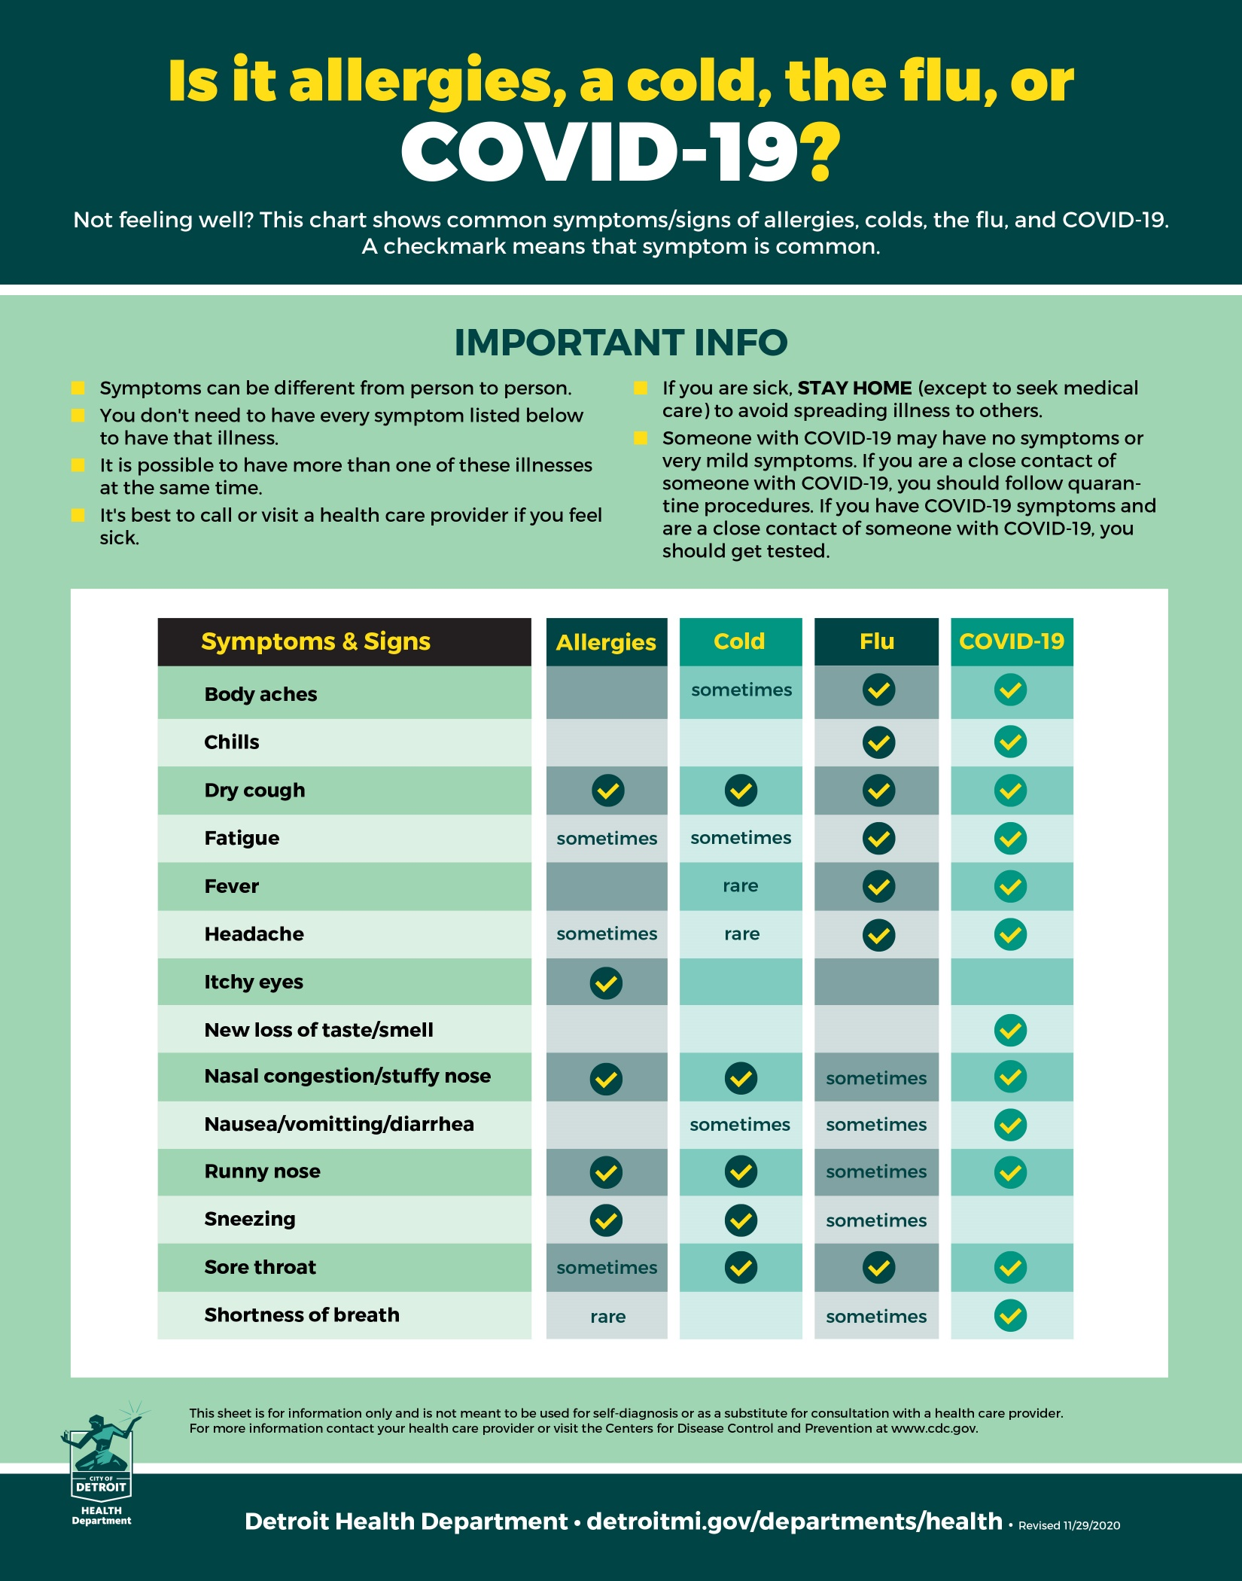

(5)
A Silver Lining Story - “My Hair’s Journey to Freedom”:
By Carolyn Doelling – Sisters from AARP
I shrieked in horror. The wedding was in two days and the mother of the groom was bald. My hair was sending a message, ‘I’ve had enough of chemicals”. For decades I straightened and colored my hair. In my early years, I reached for the straightening comb. Later, I relied on relaxers to tame my hair. Throughout my adult life, at the first glimpse of gray roots, I was in the stylist’s chair. Two days before my son’s wedding, I went to my hair stylist for the usual perm touch-up and color. Getting my hair done was the last thing on my to-do list. I was packed. The mother-of-the-groom dress was a knockout. My flight and luxury hotel room were booked. One hundred and fifty relatives and friends and I were on our way to the Big Easy. All of us were looking forward to the vows, the wedding festivities and a celebration.

Giddy with anticipation, my hair stylist and I chatted and giggled incessantly throughout the application of the perm, the shampoo and the conditioning treatment. When I moved back to the styling chair for the blow dry, I shrieked in horror when I saw my mirror image. There were two very large bald spots where there had been hair just 15 minutes prior. She cringed in embarrassment, apologizing profusely, “what happened? I used the same perm and color I’ve used for the past five years”. Each night I inspected my scalp to see a slow-growing, gray fuzz. As it grew longer, I became more curious about where it was leading me. What was the texture of my natural hair? How gray was it? Salt and pepper? Silver? I was mortified. The wedding was in two days and the mother of the groom was bald. It was as if my hair was sending me a message, “I’m tired. I’ve had enough. Over 60 years of hot combs and harmful chemicals. Enough already! I want my freedom. I want to show you who I really am.”
The stylist stayed up around the clock weaving a wig for me. On the wedding day, no one seemed to notice that the cute pixie was not real. I kept the wig a secret for months. Each night I inspected my scalp to see a slow growing gray fuzz. As it grew longer, I became more curious about where it was leading me. What was the texture of my natural hair? How gray was it? Salt and pepper? Silver? After about six months, my hair had grown enough that the wig no longer fit properly. I reluctantly removed it to showcase my new look. Initially, I was extremely self-conscious to go outside, let alone to visit friends. But as time passed, the hair grew into an astonishing curl pattern — hundreds of tiny silver curls. Its thick but soft texture fascinated me. I never imagined that it might be so beautiful.
The numerous random compliments I received from strangers inspired me even more. Just last week a young man in his late 30s driving a fancy Corvette honked loudly at me as I walked down the street. He yelled out how much he liked my hair. Interestingly, the only people with negative comments have been the males in my own family. They prefer a straight look and think the gray hair makes me look older. No matter those opinions, the benefits are undeniable. Wearing my hair natural and gray has changed my life in many social/emotional ways. For example:
- I no longer hate the wind, “those wind gusts that undo the work of a curling iron in seconds”. I can drive fast with the sunroof open or ride in a convertible with the top down and enjoy the breeze.
- I am in better physical shape and stronger than I have ever been. I work out every day without worrying about sweating out the perm. My gray hair motivates me to work harder in group exercise classes just to show that I can.
- I’ve found a new tribe. I have become part of Silver Sisters International and Celebrate the Gray; two notable organizations promoting a gray hair movement around the world.
- I’ve found work as a model.
- I’m saving hundreds of dollars a year. During my lifetime, I have spent tens of thousands of dollars at beauty shops. Now I have products to maintain my own hair. I see my stylist once every few months rather than every few weeks.
I’d like to say that embracing my gray hair was a conscious decision fueled by a pursuit of authenticity. But truthfully, I would, in all likelihood, still be coloring and perming my hair were it not for that fateful hair appointment before the wedding
two years ago. I was understandably horrified then, but now I am grateful. I love my hair! Since the pandemic and stay-at-home orders, my hair has grown another two inches giving me an even more unique look. I’m curious to see where the hair is leading me next. For now, it’s sufficient to know that it feels free and, in many ways, it has freed me.

If you have a story or great ideas that you think of interest to our members, please e-mail them to Kelly Vick and your point of interest will be listed in The Chronicle (sandkvick@nc.rr.com).

SOME EXAMPLES
Silver Lining Story
Favorite Recipe
Statement about something special and exciting that happened to you.

