THE CHRONICLE
RALEIGH-WAKE COUNTY CHAPTER #3689
http:AARPchapter3689.weebly.com
aarp3689@gmail.com
Kelly Vick - Editor
March – April 2023

Speaker for Today  Officer Roderick Lee  Raleigh Police Department  “Police Safety Tips for Seniors”  ******************************  The Speaker in March was  Kacy Hall  Heartland Home Health Hospice  “Palliative Vs Hospice Care and Senior Care”  Chapter Officers  Co-Presidents  James Nelson  Claude Lee  Vice President  Cordelia Blackwell  Secretary  Hannah Gathings  Co-Treasurers  Willi Webb  Brenda Smith  ******************************  Committees  Community Service (Oweida Cole)  Fundraising (Lorrie Berlenbach)  Legislative (Karen Clark)  Membership (Karen Youmans)  Nominating (Allan Younger)  Program (Allan Younger)  Sunshine (Claude Lee)  Telephone (Pat Toothman)  Staff Coordinates  Ambassador (James Hines)  Historian ______________  Newsletter (Kelly Vick)  Reflections (Grace Krishnamurty)  Webmaster (Claudia Harris) |  | MESSAGE FROM OUR CO-PRESIDENTS  James Nelson & Claude Lee  Thriving After Dividing: 40 Years of Our Independent AARP Chapter  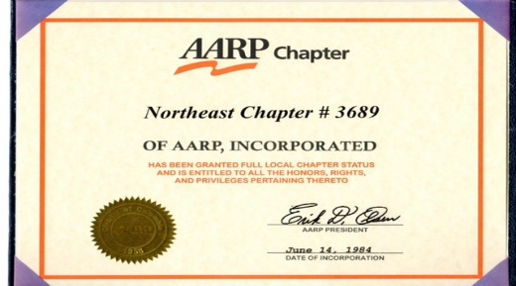  On June 14, 1984, about seventy charter members formed a new Chapter #3689 following a division from the only AARP chapter in Wake County. Despite the challenges our charter members faced, they persevered with grit, determination and a shared vision to create an independent group that would serve our community effectively.  One of our most revered Charter Members, L.C. Bruce, who passed away in 1996, left a moving message that still inspires us today: "As long as I am alive, there will be a #3689 because I love you and enjoy living with you. With the help of many of you, we shall overcome." These powerful words embody the spirit of our Chapter and remind us of the strong bonds that unite us.  From those early days of finding suitable meeting venues and recruiting enough volunteers for our noble causes, we have grown into a thriving organization that has left an indelible mark on our community. We have consistently organized various volunteer activities, including the AARP/WORKS employment planning program, the Urban Ministries Food Pantry, the Raleigh Rescue Mission, Wake Up and Read, Council on Aging, and the 55 Alive Driving program. We even hosted a multi-chapter AARP meeting in 1991, where we welcomed Raleigh Mayor Avery Upchurch and the National Executive Director of AARP, Horace Deets.  And through it all, we have remained true to our roots of building a solid community among our members. As new members join us, we welcome them with open arms, eager to keep our legacy alive.  So let's celebrate our 40th Anniversary next year with pride and joy, knowing that we have accomplished so much and have so much more to offer. Here's to our founding members and all of our members, past and present, who have helped us thrive after dividing.  We're thrilled you're a part of our journey and can't wait to see what the future holds for our AARP Chapter #3689!
COMMITTEE REPORTS

SUNSHINE
Birthday cards were mailed to members listed below who have birthdays in March and April. If you know of anyone who is ill, a bereaved family or you are having your “90th Milestone Birthday”, please call Claude Lee (919-971-3317) or e-mail him at claudealeejr@gmail.com.

MARCH BIRTHDAYS | APRIL BIRTHDAYS
Sarah Cooley (8)  George Gross (11)  Mattie Branch (12)  Allan Younger (18)  Alice Hedley (31) | Willi Webb (3)  Louise Halpern (8)  Kelly Vick (13)  Oweida Cole (19)  Alan Tally (26)

NOMINATING
We have one opening for the Nominating Committee. This person will be working with two other members recruiting an annual slate of qualified candidates for all offices.

TELEPHONE
A special “Thank you” to Helena Nabors for volunteering as a telephone caller. Some members have volunteered to call members on their birthdays, as well as Claude Lee sending out cards. Donations of cards or stamps are appreciated. Let us remember previous members or those who are isolated or lonely by phoning or sending a card. We need a third caller. Contact me if you could help. This person will be calling between 12-15 members monthly with monthly meeting information.

FUNDRAISING
The Fundraising Committee is in the process of planning the Jazz Event for this Fall.

MEMBERSHIP
We are available for membership renewals or if someone would like to join our chapter. Our chapter membership dues are $10.00 per year. You must be a member of the National AARP and you will need your national membership card to complete the renewal form and the membership form. These forms are on our website with instructions on where to mail it.

COMMUNITY SERVICE
Claude Lee and Oweida Cole continue to volunteer at the Food Pantry on the second Monday of the month and in some instances, whenever they need volunteers if they are short on any particular day. Our task consist of packing groceries, meats and vegetables, as well as bread and pastries and taking them outside to be loaded into automobiles. Let Oweida know (919-803-7569) when you are ready to volunteer, usually from 8:30 to 10:30.

******************************************************************************************

Did you know that our Co-President Claude Lee has organized a Card Playing session where you can play BID WHIST or SPADES. Please get in touch with Claude via text or phone call at 919-971-3317 if you are interested in attending.

(2)

Claudia Harris’ Family History: A Proud African-American Lineage

I often like to share my family history and some of the contributions my ancestors have made to the proud legacy of African-Americans in the United States and, more specifically, to South Carolina. Although I was born and raised in New York City, my roots originate in the Carolinas. Both my parents, Chambers T. Brayboy and Clelia Albert Brayboy were South Carolina natives who met when they were students at South Carolina State College (now University). On my paternal side, I can trace my ancestry from 1700s North Carolina to 1800s South Carolina and beyond. My maiden name, Brayboy, formerly Braveboy, belonged to a tri-racial group of free people of color (Free Issues) who were arbitrarily recorded as Black, Indian, White and/or Mulatto. In fact, there are many members of the Lumbee tribe today who bear the Brayboy name. On my maternal side, my ancestors were previously enslaved (presumably in South Carolina). Within only two generations, they were able to rise out of poverty, become prominent members of their communities and produce an activist in the struggle for equal rights who would become the first Black to be elected to the South Carolina Senate since Reconstruction.

Perhaps the most illustrious relative on my paternal side was Joshua Braveboy, my 4th Great Grandfather. Born in 1740 in North Carolina, he migrated in 1771 to South Carolina from the Indian settlement on Fishing Creek in Granville County. Almost 240 years ago, Joshua participated in the birth of our country. He was a free person of color, who served in the South Carolina militia during the American Revolution under General Francis Marion (1780-81) and in another militia unit in 1782. He was one of approximately 5000 Black Patriots who enlisted to fight for freedom from the yoke of Great Britain. He received a land grant of 150 acres on Two Mile Branch at Lynches Creek near present day Scranton, South Carolina after petitioning the Colonial Royal Governor’s Council of South Carolina. I have copies of his land plat and the petition for his American Revolution pension. He became a successful planter and went on to raise a prominent family. By emancipation, his descendants had acquired over 5000 acres of land. Today, a historic marker is prominently placed at the location of Joshua’s former plantation where he is presumed to be buried (see the picture below on the left).

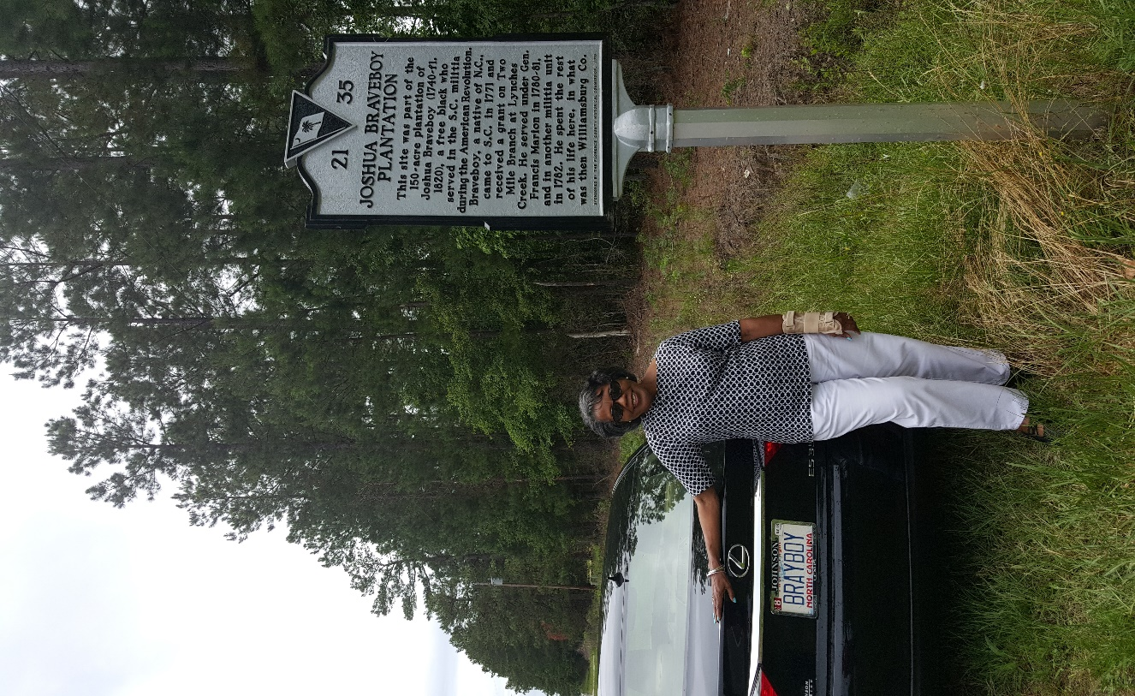 | 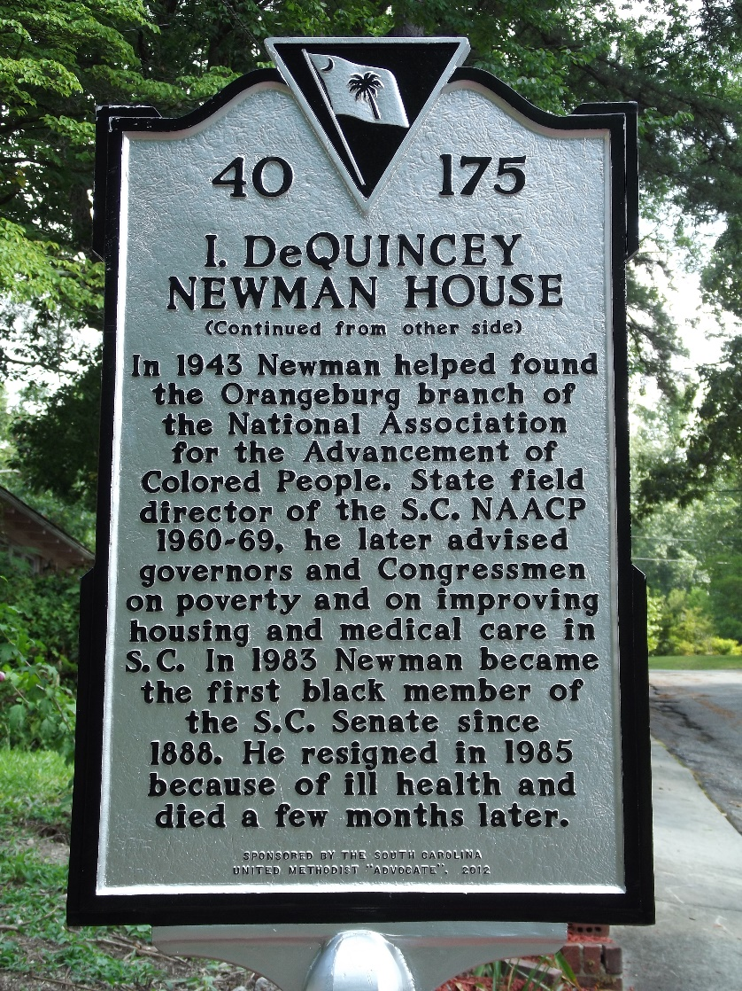
Historic Marker at Joshua Braveboy Plantation  Here I am at the site of my 4th Great Grandfather’s Plantation. Notice my license plate. | Historic Marker at the site of the I. DeQuincey Newman House in Columbia, S.C.
(3)
Claudia Harris’ Family History (continued)

Joshua’s son, Lewis, my 3rd Great Grandfather, recorded a plat for 118 acres on Crackers Neck near the Savannah River in Orangeburg, South Carolina. In the 1800 census, Lewis was taxable on 300 acres in Winton, Barnwell County; the same area where my father would be born more than 100 years later.

Throughout the years, land ownership was an important means of acquiring generational wealth for the Braveboy/Brayboy family. Sadly, in the 1950s, our family was among those who were forced by the US government (via eminent domain) to surrender land that had been in the family for years in order to construct the Savannah River Nuclear Plant.

Turning to my maternal lineage, my mother was descended from formerly enslaved people who settled in and around Darlington County, South Carolina after the Civil War. She was part of the Albert, King, Newman, and Morris families. Her nuclear family consisted of three girls and five boys, all of whom went on to pursue military service or higher education. Hartsville, the community she lived in as a child, was a close knit one with an extended family of cousins, aunts, uncles, and grandparents living nearby. They were in and out of each other’s homes. What they may have lacked in material wealth was made up for in familial pride.

Isaiah DeQuincey Newman and my mother were first cousins who grew up together. In our family, he was known simply as DeQuincey. Born in 1911 in Darlington County, he was the child of Rev. Milton C. Newman and Charlotte (Lottie) Morris Newman. (My grandmother, Alice Morris Albert was Lottie’s sister.) His mother died of tuberculosis when he was just five years old and he was sent to live with his maternal grandmother in Hartsville. As a young boy, he earned money by shining shoes on street corners and in shops. During a visit to his father’s home when he was eight years old, he witnessed the KKK set fire to a caboose holding an African-American prisoner. Hearing the man’s screams, he begged his father to help. His father didn’t. For a long time, DeQuincey held this against him until he later realized that his father would have met the same fate as the prisoner had he intervened. This seminal event spurred in him a life-long pursuit for a just society.

DeQuincey attended Claflin College and was a graduate of Clark College and the Gammon Theological Seminary. He was ordained in the United Methodist Church in 1931 and would serve in United Methodist Churches in Georgia and South Carolina for the next 40 years. He was to become one of South Carolina’s most prominent civil rights leaders. His illustrious career spanned several decades. He founded and directed the Society for the Preservation of Black History, Art, and Folklore. Originally a member of the Republican Party, he became increasingly dissatisfied with its position on segregation. By 1958, he had switched his affiliation to the Democratic Party, where he served as a delegate to the 1968, 1972 and 1980 Democratic National Conventions. He is credited with assisting in the foundation of the Democratic Progressive Party. He helped organize the Orangeburg branch of the NAACP in 1943 and served the South Carolina NAACP as state field director from 1960 to 1969. From 1972 to 1974, he served as executive assistant to the director of the South Carolina Department of Social Services. In 1979, he was awarded the Order of the Palmetto. From 1974 to 1981, he was director of the Governor’s Rural Regional Coordination Demonstration Project. He served as US Special Ambassador, along with John Glenn, when the Solomon Islands were granted independence from Great Britain. That same year, he was presented at the Court of St. James’ in London. He was the confidante of many of South Carolina’s most distinguished leaders in government. In 1983, at age 72, he became the first Black elected to the South Carolina Senate since Reconstruction. At his death, his friend, US Senator Fritz Hollings said “The Rev. Newman’s life is testimony to the transformation this country has undergone in the last 30 years. He not only was there to pry open the door of opportunity, he walked through it. In the years when equal justice under the law was only a dream for people of his race, the Rev. DeQuincey Newman was on the front line fighting the battles that dismantled the structure of segregation and discrimination, along with Martin Luther King Jr. and Roy Wilkins.”

Posthumous Highlights:
- 1n 1985, the Middleton-Rosemond United Methodist Church name was changed to I. DeQuincey Newman United Methodist Church.
- In 1986, the Richland County Legislative Delegation and the Highway Commission dedicated South Carolina Highway 277 as the I. DeQuincey Newman Freeway.
- On January 20, 1987, Unveiling of the Portrait of I. DeQuincey Newman in the South Carolina Senate Chamber.
- In 2001, the University of South Carolina created the I. DeQuincey Newman Institute for Peace and Social Justice and an endowed chair position of the same name, held in the College of Social Work.
- In 2012, Unveiling of an historical marker at the site of the I. DeQuincey Newman home in Columbia, South Carolina.

I remember DeQuincey as a brilliant, caring, thoughtful, and unassuming gentleman. He did not flaunt his accomplishments and was just another member of our family. He was a force for good, for change, and for social justice. I am so proud of him and consider it such a privilege to have known him. (See his historic marker on page 3.)

His life is chronicled in The Spirit of an Activist: The Life and Work of I. DeQuincey Newman edited by Sadye L. M. Logan.
(4)

CONGRATULATIONS!!!
At our February meeting, our Co-Presidents had the pleasure of giving out gifts to the following eleven lucky members: Brenda Bennett, who invited one guest; our special meeting winners, Alan Talley, Willi Webb and Hannah Gathings; our new members, Donna Bergeron, Sarah Cooley, Rosa DeVega, Cheryl Gill, Tom Gill, Brenda Johnson and Cleotis Johnson. Each winner received our “Proud AARP Chapter lunch bag”. (See the picture below:)

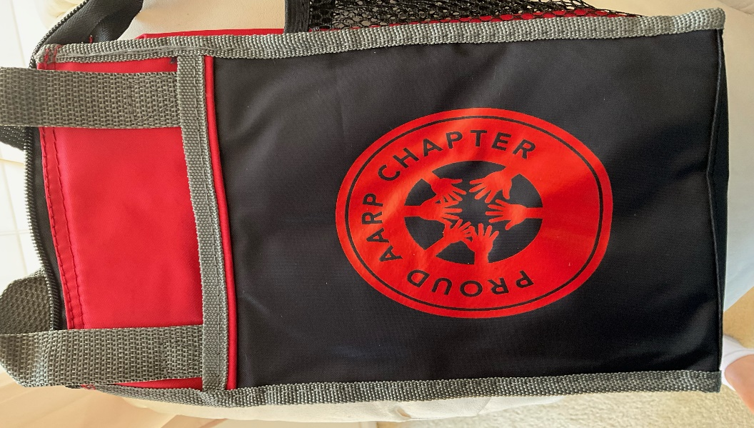

**************************************************************************************************

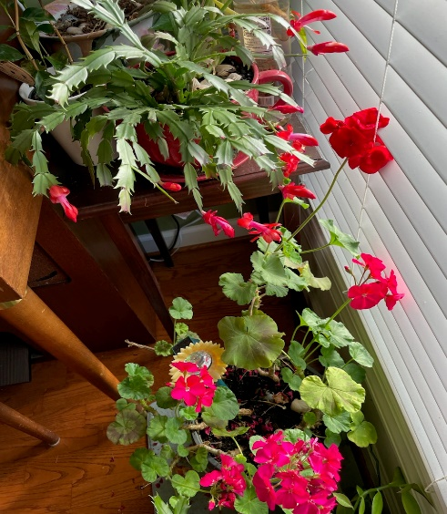 | Ten Healthy Foods  You Can Eat Without Gaining Weight  Indulge in these to your heart’s content, along with a balance diet.  - Celery  - Lettuce  - Watermelon  - Broccoli and Cauliflower  - Grapefruit  - Mushrooms  - Berries (strawberries, blueberries, blackberries)  - Kiwi  - Carrots  - Spinach and kale
Oweida Cole’s beautiful Cactus and Begonia  “Bloomed in February for Valentine’s Day” | From  AARP Health

************************************************************************************************************

If you have a story or great ideas that you think of interest to our members, please e-mail them to Kelly Vick at sandkvick@nc.rr.com and your point of interest will be listed in The Chronicle. See Examples below:
Silver Lining Story
Favorite Recipe
Statement about something special and exciting that happened to you.

(5)

