THE CHRONICLE
RALEIGH-WAKE COUNTY CHAPTER #3689
http:AARPchapter3689.weebly.com
aarp3689@gmail.com
Kelly Vick - Editor
September – October 2022
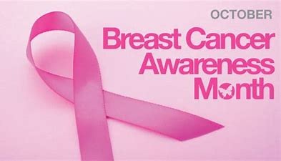  Chapter Officers  Co-Presidents  Gayle Gayton  Willi Webb  Vice President  Cordelia Blackwell  Co-Secretaries  Hannah Gathings  Claude Lee  Pat Toothman  Gwenn Weaver  Co-Treasurers  Cynthia Bradley  Claudia Harris  Nominating  Allan Younger  ******************************  Committees  Community Service (Oweida Cole)  Fundraising (Lorrie Berlenbach)  Legislative (Karen Clark)  Membership (Karen Youmans)  Program (Allan Younger)  Sunshine (Claude Lee)  Telephone (Pat Toothman)  Staff Coordinates  Ambassador (James Hines)  Historian (Thelma Blake)  Newsletter (Kelly Vick)  Reflections (Grace Krishnamurty)  Webmaster (Claudia Harris) |  |  | MESSAGE FROM OUR VICE PRESIDENT  (Cordelia Blackwell)  ♪♪♫ Getting to know you – Getting to know all about you… ♫♪♪  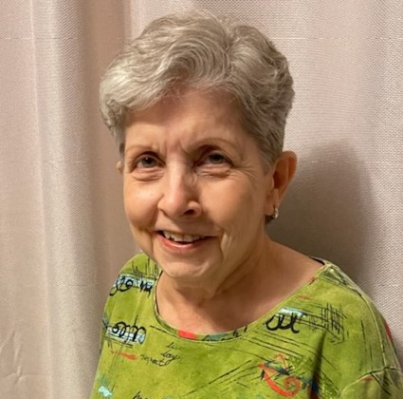  It’s October! Where has the time gone? November is voting and Thanksgiving – December is winter and Christmas. But for us as the time passes, we are getting to know more and more about our AARP members. So let’s get started with our Telephone Committee Chairperson, Pat Toothman.  Cordelia: Where did you grow up and how did you get to the Raleigh area?  Pat: I was born and raised in the hills of West Virginia. Getting to Raleigh is a series of locations. First, we moved to Endicott, New York, then to Hanau, Germany and back to Endicott, New York. Next we relocated to Morgantown, West Virginia, then to Columbia, South Carolina and finally to Raleigh, where we have lived for 35 years. This moving was due to a series of events: marriage, Dennis drafting into the Army, returning for him to complete school and of course job locations.  Cordelia: Did you come from a small or large family and tell us about your family now?  Pat: First, from a family of immigrants. Paternal grandparents immigrated from Hungary and maternal grandparents from Italy all through Ellis Island in early 1900s. Both grandfathers and my dad were coal miners. I have been married for 34 years. Dennis and I have two sons - Nathan, who graduated from UNC Wilmington and manages a furniture store in Fernandina Beach, Florida and Brian, who graduated from UNC Charlotte. Brian also has a Master’s Degree from NC State and is employed with Microsoft. We have been blessed with four grandsons (brothers), who reside in Apex. Dennis is a graduate of West Virginia University and has been employed at several high tech companies, including starting his own company, CipherOptics.  Cordelia: You are such a friendly and outgoing person. Tell us how your caring personality has helped you.  Pat: Being exposed to so many people over the years in different situations has helped me adjust to anything. Being an RN has especially contributed to my caring attitude, as well as the love of animals.  (Interview continued on page 4)
OCTOBER HEALTH FAIR  ATRIA Oakridge  10810 Sandy Oak Ln., Raleigh, NC 27614  Thursday, October 20, 2022  11:00 AM – 1:00 PM  Regular AARP Meeting  REGISTER WITH TELEPHONE COMMITTEE | TOPICS  AUDIOLOGY  EYECARE  PHYSICAL THERPY  GENERAL WELLNESS  BONE HEALTH  50/50 SUPER JACKPOT FUNDRAISER  LUNCH - $10.00

************************************************************
Pumpkin Soup for the Fall | Ingredients  - 6 cups chicken stock  - 4 cups pumpkin puree  - 1 cup chopped onion  - 1 clove garlic, minced  - 1 ½ teaspoons salt  - ½ teaspoon chopped fresh thyme  - 5 whole black peppercorns  - ½ cup heavy whipping cream  - 1 teaspoon chopped fresh parsley | Directions  - Place chicken stock, pumpkin puree, onion, garlic, salt, thyme, and peppercorns in a large pot; bring to a boil. Reduce heat to low and simmer uncovered for 30 minutes. Transfer soup to a blender or food processor in batches; blend until smooth. Return soup to the pan and bring to a boil; reduce heat to low and simmer uncovered for 30 minutes. Stir in heavy cream. Ladle soup into bowls and garnish with fresh parsley.

(2)
COMMITTEE REPORTS

SUNSHINE
Birthday cards were mailed to members listed below who have birthdays in September and October. If you know of anyone who is ill, a bereaved family or you are having your “90th Milestone Birthday”, please call Claude Lee (919-971-3317) or e-mail him at claudealeejr@gmail.com.
SEPTEMBER BIRTHDAYS |  | OCTOBER BIRTHDAYS
Cynthia Bradley (8)  Alvita Roberts (10)  Brenda Smith (13)  Mary Weathers (26)  Claude Lee (28) |  | Anne Best (2)  Brenda Bennett (18)  Kathy Auxer (20)  Karen Clark (21)

NOMINATING
We have six openings for officers to be filled by year end 2022; (Co-President - 2 openings, Vice President, Co-Treasurer - 2 openings and Secretary). The Nominating Committee will be contacting chapter members to fill these positions.

TELEPHONE
Pat Toothman, Claude Lee and Cordelia Blackwell are calling members monthly as a way of keeping in touch in this virtual world for the past two years and providing Chapter information. Some members have volunteered to call members on their birthdays, as well as Claude Lee sending out cards. Donations of cards or stamps are appreciated. Let us remember previous members or those who are isolated or lonely by phoning or sending a card.

FUNDRAISING
Please make all checks payable to AARP Chapter #3689
and mail your check to the address below:
Claudia Harris
412 Dimock Way
Wake Forest, NC 27587
(1 ticket for $3.00 and 2 tickets for $5.00)
A picture of the ticket stubs will be e-mailed or texted to you.

MEMBERSHIP
We will start collecting 2023 membership renewals in November. Our chapter membership dues are $10.00 per year. You must be a member of the National AARP and you will need your national membership card to complete the membership form. The membership form is on our website with instructions on where to mail it.

**************************************************************************************************

A GREAT Book To Read – “It Ends with Us” – By Colleen Hoover
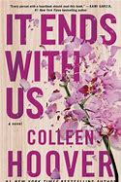 | In this “brave and heartbreaking novel that digs its claws into you and doesn’t let go, long after you’ve finished it” from the #1 New York Times bestselling author of All Your Perfects, a workaholic with a too-good-to-be-true romance can’t stop thinking about her first love. Lily hasn’t always had it easy, but that’s never stopped her from working hard for the life she wants. She’s come a long way from the small town where she grew up—she graduated from college, moved to Boston, and started her own business. And when she feels a spark with a gorgeous neurosurgeon named Ryle Kincaid, everything in Lily’s life seems too good to be true. Ryle is assertive, stubborn, and maybe even a little arrogant. He’s also sensitive, brilliant, and has a total soft spot for Lily. As questions about her new relationship overwhelm her, so do thoughts of Atlas Corrigan—her first love and a link to the past she left behind. He was her kindred spirit, her protector. When Atlas suddenly reappears, everything Lily has built with Ryle is threatened.
Did you know you can download free books from the Library with your Library Card? Contact your community Library and they will assist you in downloading books.
(3)
Cordelia Blackwell’s Interview with Pat Toothman
(Continued from page one)

Cordelia: Tell us about your education and career and what positions you have held.
Pat: I must start with my early years, as this is quite a story. The first four years of school were in a two- room structure - one room for teaching and the other for eating. We had a school cook who made hot lunches that were always tasty. Also, we had an outside privy. On snowy and cold days we bundled up to use it. Which was very difficult for little ones. We always started the day with the “Pledge of Allegiance” followed by “The Lord’s Prayer”. All this was very primitive by today’s standards. I lived with no running water until age 15 and a privy also until then. Fifth grade required moving to a different school, that had indoor plumbing and that was really appreciated. On to high school - I played trumpet, trombone and baritone horn, as well as being a majorette in the marching band. After I graduated from high school, I went to Fairmont State College and earned an Associate Degree in Business and Secretarial Science and began working for Monongahela Power in Fairmont, WV. Upon marrying Dennis, we moved to Endicott, NY and I worked for IBM in Cost Engineering. With his second year in the Army, we moved to Hanau, Germany and I worked for Davis Agency in Frankfurt. Then back to Endicott for a short while and returned to Morgantown where Dennis finished school. At that time, I worked for Rockwell International as secretary and administrative assistant to the Comptroller and Vice-President of Engineering. Upon Dennis' graduation, we moved to Columbia, SC and I returned to college and received an RN Degree in Nursing from the University of South Carolina and worked for Richland Memorial Hospital. We then moved to Raleigh and I retired from Rex Hospital where I worked in the Pulmonary, renal and cardiac unit.
Cordelia: Do you enjoy traveling and are there places you found interesting?
Pat: While in Germany we did travel to several cities. American Express offered discounts to the military and dependents. We went skiing in Lientz, Austria and Garmisch Purchase Garden in the Bavarian Alps. Dennis skied and unfortunately I just snowplowed and fell frequently. We traveled to London; Trafalgar Square, the Tower of London, St. Paul’s Cathedral, Buckingham Palace for the changing of the guard and Madame Tussaud’s Wax Museum. While at Davis Agency I worked for Retired Colonel Raymond Roberts, former head of the Berlin Brigade. He arranged a train trip to West Berlin for us. At that time the city was still divided. The “Wall” was still there, with East German border guards with rifles.
Cordelia: What are your favorite color, food, book and movie?
Pat: I like shades of pink and lavender. Enjoy Chinese and Indian foods. Nice and spicy. I rarely went to movies, but with Hulu I see many of them now for free. I tend to like romance and comedy.
Cordelia: What are your hobbies and interesting things you like to do?
Pat: I have rented space at antique stores over the years. I find interesting items at estate sales, thrift stores, yard sales, etc. – enjoying the hunt for that “Diamond In The Rough”. Years ago, Dennis and I taught beginning ballroom dancing for a while and went dancing in different places frequently.
Cordelia: Tell us something you would like us to know about you?
Pat: I have MS, but am blessed I can go to the gym, participate in daily activities, etc. I have always looked at my glass as “Half Full” rather than “Half Empty”.
************************************************************************************************** James Nelson’s plants under the Aerogarden lights and the background trees outside his home. Check out his plaque on the right wall commemorating the Voting Rights Act.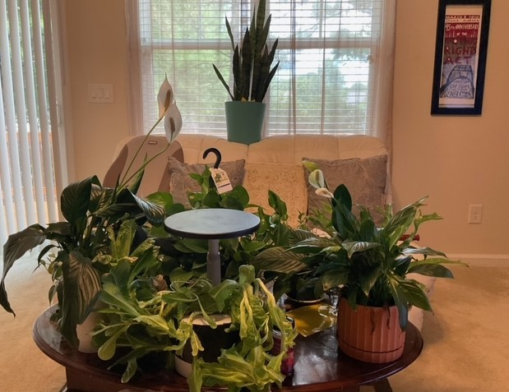
(4)

