THE CHRONICLE
RALEIGH-WAKE COUNTY CHAPTER #3689
http:AARPchapter3689.weebly.com
aarp3689@gmail.com
Kelly Vick - Editor
January – February 2023

Speaker for Today  Allan Younger II  “Emancipation Proclamation”  ******************************  The Speaker in January was  Rick Messemer  Certified Senior Advisor  “Documents  Every Senior Should Have”  Chapter Officers  Co-Presidents  James Nelson  Claude Lee  Vice President  Cordelia Blackwell  Secretary  Hannah Gathings  Co-Treasurers  Willi Webb  Brenda Smith  ******************************  Committees  Community Service (Oweida Cole)  Fundraising (Lorrie Berlenbach)  Legislative (Karen Clark)  Membership (Karen Youmans)  Nominating (Allan Younger)  Program (Allan Younger)  Sunshine (Claude Lee)  Telephone (Pat Toothman)  Staff Coordinates  Ambassador (James Hines)  Historian ______________  Newsletter (Kelly Vick)  Reflections (Grace Krishnamurty)  Webmaster (Claudia Harris) |  |  | MESSAGE FROM OUR CO-PRESIDENTS  James Nelson Claude Lee  Fellow Chapter Members,  We are absolutely thrilled to be taking on the Co-President role and have the opportunity to work alongside everyone. Your commitment and passion in our chapter have inspired us, and we are excited to build on that foundation as we move forward.  One of the things we are most looking forward to is working together as a team, collaboratively. The strength of our chapter lies in the involvement and cooperation of our entire membership and we believe that by working together, we can achieve even more in the coming months and years. We encourage every one of you to get involved in chapter activities and to bring your ideas and energy to the table.  In terms of new projects, we are very eager to explore new ways in which we can engage with and serve our community. Whether it's through volunteering, educational events, or community outreach, there are endless possibilities for making a positive impact. We are quite confident that with your help, we can make this happen.  And, of course, we will have plenty of fun along the way! We believe being active and engaged in our community should be enjoyable and fulfilling. We look forward to creating new opportunities to come together and celebrate our shared experiences.  Finally, we offer our sincerest compliments to all of you for the incredible work you have done thus far. Your dedication to our community and your unwavering commitment to making a positive impact is truly inspiring. We are very grateful to be a part of this chapter and we are confident that together, we will continue to make a difference.  Thank you for your time and we look forward to working with every one of you.  Best regards,  Your Co-Presidents

MESSAGE FROM OUR VICE PRESIDENT
(Cordelia Blackwell)
♪♪♫ Getting to know you – getting to know all about you… ♫♪♪

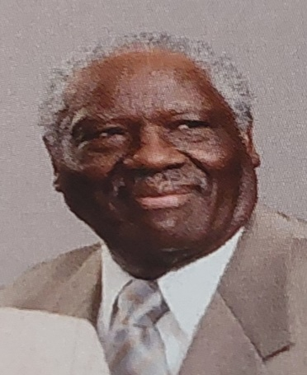
We are into a new year – hopefully healthier and happier. And as we continue getting to know each other, I’ll quote Sister Sledge, “We are Family”. So let’s get to know another one of our family members, Felex Gathings.

Cordelia: Where did you grow up and how did you get to the Raleigh area?
Felex: I grew up in the small town of Egypt, Mississippi where my family operated a 367 acre farm. We raised beef cattle, chickens, hogs, cotton, corn, soy beans and hay. I came to Raleigh when a section of my company in Corinth, Mississippi relocated to Raleigh in 1968.
Cordelia: Did you come from a small or large family and tell us about your family now.
Felex: My family was large. I was the 7th out of 12 children. My wife Hannah and I have 3 adult children, 5 grandchildren and 2 great grandchildren.
Cordelia: You seem to like playing cards and you seem to be a good player. Are you skillful and lucky at cards?
Felex: Yes, I like playing cards and I try to play a strategy game; waiting for others to make a mistake.
Cordelia: Tell us about your career and what are some of the positions you have held?
Felex: My career has been interesting. After graduating from Jackson State University in Jackson, MS with a B.S. in Mathematics and Physics, I was drafted. I chose the Navy because of their state-of-the-art electronic training and the ability to travel. I graduated in the top 3rd of the class and was the only African American student. My first job title was Electronic Technician for ULTA High Frequency equipment on the USS Dahlgren DLG-12, a Guided Missile Destroyer, for which I had to get a Top Secret Clearance. After the Navy, I worked with ITT in Mississippi until I relocated to Raleigh. After three years in Raleigh, ITT downsized. My last job was with Raleigh/Durham Airport Authority as Administrator of Computerized Devices and I retired in 2002 with 15 years of service.
Cordelia: Do you enjoy traveling and are there places you found interesting?
Felex: Yes, I love traveling. The most interesting place I have visited is Istanbul, Turkey. Turkey occupies two continents. You can stand on the Bosphorus Bridge and have one foot in Europe and the other foot in Asia.
Cordelia: What is your favorite color, food, book, and movie?
Felex: My favorite color- blue, food- sweet potato, book- The Invisible Man, movie- The Graduate.
Cordelia: What are your hobbies and interesting things you like to do?
Felex: Playing Bid Whist, Pinochle, and Bridge are some of the things I like to do.
Cordelia: Tell us something you would like us to know about you.
Felex: My wife Hannah and I have visited 26 of the 50 United States. We flew to five of the states and drove to the other states.

(2)

COMMITTEE REPORTS

SUNSHINE
Birthday cards were mailed to members listed below who have birthdays in January and February. If you know of anyone who is ill, a bereaved family or you are having your “90th Milestone Birthday”, please call Claude Lee (919-971-3317) or e-mail him at claudealeejr@gmail.com.
JANUARY BIRTHDAYS | FEBRUARY BIRTHDAYS
Stewart Vick (4)  Edmond Gayton (20)  Felex Gathings (25) | Betty Franks (2)  Gayle Gayton (12)  Leon Cook (23)  Kenneth Clark (28)

NOMINATING
We have two positions to be filled:
(1) Nominating = Responsible for recruiting an annual slate of qualified candidates for all offices.
(2) Historian = Maintain chapter records including all documents and photos of chapter activities.

TELEPHONE
Committee members are calling members monthly as a way of keeping in touch in this virtual world for the past three years and providing Chapter information. Some members have volunteered to call members on their birthdays, as well as Claude Lee sending out cards. Donations of cards or stamps are appreciated. Let us remember previous members or those who are isolated or lonely by phoning or sending a card. A special “thank you” to Beverly Clark for volunteering as a telephone caller. We still need another caller. Contact Pat Toothman (919-846-8477) if you are willing to help. This person will be calling between 12-15 members monthly with monthly meeting information.

FUNDRAISING
We had the Super Jackpot 50/50 drawing at the January meeting. Congratulations to the winner, Cordelia Blackwell.

Our next committee meeting is scheduled for Tuesday, February 21st at 7:30 pm. If you have any fundraising ideas, please share with the committee. This way we can start thinking about new and existing ways to move forward.

MEMBERSHIP
We are collecting 2023 membership renewals. Our chapter membership dues are $10.00 per year. You must be a member of the National AARP and you will need your national membership card to complete the membership form. The membership form is on our website with instructions on where to mail it. If you can’t access the website, a copy of the form is on page 7 of this Chronicle.

COMMUNITY SERVICE
"You may never know what results come of your actions, but if you do nothing, there will be no results." (Mahatma Gandhi)

Community Services has continually made an effort to practice kindness towards others and I am very pleased to be a part of an organization and a committee that practices these results "TO SERVE, NOT TO BE SERVED".

During the last year, we've logged in over 500 + volunteer hours at various locations. Our endeavors included collecting and delivering items such as school supplies, socks, mittens, hats, clothing, coats, science experiment items and snacks. These items were delivered to Fox Road Magnet School, Healing Transitions, Salvation Army, Loaves and Fishes and a new facility “Note in the Pocket”.

Personally, I am elated to be able to render these services to these organizations. Needless to say, I would never be able to deliver these items were it not for ALL of you who contributed. So, I would like to take this time to thank you for your participation and our occasional congregation at Kohl's Parking Lot.

Spread some extra warmth and light during this final month of winter! Spring is on the Way!

(3)
2023 BLACK HISTORY THEME:
BLACK RESISTANCE
Across the country, February is recognized as Black History Month. Do you know what the month means and how you should take part in the month-long observance?

The month is meant to recognize the struggles, adversity, strength and history of the Black American experience in the United States. Historical recollections, observations and materials are available in dedication to the month through the Library of Congress, the National Archives and Records Administration, the National Endowment for the Humanities, the National Gallery of Art, National Park Service, Smithsonian Institution and the United States Holocaust Memorial Museum.

The first observance was only a weeklong, celebrated as Negro History Week in February 1926 at the creation of the Association for the Study of Negro Life and History (now the Association for the Study of African American Life and History). The week was chosen because it included both Abraham Lincoln and Frederick Douglass’ birthdays, according to an essay by Daryl Michael Scott at Howard University. Its popularity grew over the following decades as city proclamations began acknowledging the observance.

Negro History Week was approaching its fiftieth anniversary in 1976 when the country celebrated the bicentennial. It was this year that the week was extended, becoming Black History Month. President Gerald R. Ford asked Americans to “seize the opportunity to honor the too-often neglected accomplishments of black Americans in every area of endeavor throughout our history,” according to Scott. Every president since has issued a proclamation recognizing the month.

Resources for education and understanding are available at each of the aforementioned organization’s websites. Further, throughout Black History Month, NonStop Local will be covering regional stories in participation of the observance. Look out for future stories on local leaders, Black history in Tri-Cities, Yakima and Eastern Oregon, notable events and more.

The theme for the 2023 Black History Month is Black Resistance, specifically noting the strength of African Americans in resisting oppression of various forms throughout history and in the present day. Observers are asked to study the history of Black Americans’ responses to establish safe spaces for Black life’s sustainability, fortification and respect.

“African Americans have resisted historic and ongoing oppression, in all forms, especially the racial terrorism of lynching, racial pogroms, and police killings since our arrival upon these shores…” said the Association for the Study of African American Life and History’s 2023 theme announcement. “The 1950s and 1970s in the United States was defined by actions such as sit-ins, boycotts, walk outs, strikes by Black people and white allies in the fight for justice against discrimination in all sectors of society from employment to education to housing.” The question remains, how should you take part in the observance? The best way, according to the ASALH, is to educate yourself on black experience and history, with an emphasis on Black Americans' resistance to oppression. (This article is written by Karlee Van de Venter digital Content Producer.)
Celebrate Black History Month: Things to See and Do  (Submitted by Gayle Gayton)  This February check out the programs, exhibits and historic landmarks Raleigh has to offer that honor the contributions of African Americans. The list is too long to list all the options. Additional information: City of Raleigh Parks News. A few highlights are listed below:  Weekday tours of the Pope House Museum  MLK Memorial Gardens  Raleigh Trolley Celebrates Black History Month  Black History Trivia  Rise Up! Poems of Protest - Poems of Praise  Mt. Hope Cemetery |  | “We Built This” exhibit in Raleigh highlights black architects who helped build NC  https://share.newsbreak.com/2xtcabli  A traveling exhibit is giving people an opportunity to learn more about the Black architects who helped build North Carolina. The exhibit is at the historic Oak View County Park in east Raleigh. The "We Built This" exhibit highlights more than two dozen personal profiles and historic context on key topics including slavery and reconstruction; the founding of historically Black colleges and universities and Black churches; Jim Crow and segregation; and the rise of Black politicians and professionals. The tour is free and runs through March 27.
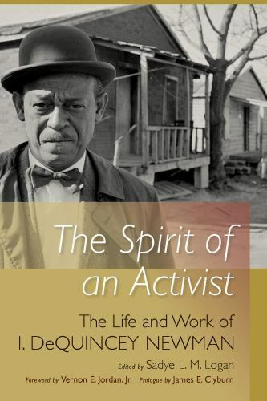 |  | LIVING IN COLOR  A Black History Month Artist Exhibit  Living Color: A new exhibit curated by the Raleigh Film and Art Festival is a riveting display of visual art representing the experience of people of color living in the south. Enjoy an array of spectacular pieces by professional and students artists in the Chapel all month long.  - On display through Sunday, February 26, 2023  - Exhibit hours are Saturday 10am – 4pm and Sunday 12 – 5pm  - Located in the Dorothea Dix Park Chapel, 1030 Richardson Drive, Raleigh, NC 27603
SUGGESTED READING FOR BLACK HISTORY MONTH  Claudia Harris cousin’s book. |  | Submitted by  Pat Toothman

Welcome to Project PIVOT:
This program involves filling and delivering additional food boxes to supplement at-risk children in our schools with healthy snacks and meals. For additional information contact: nrobertson@urbanmin.org – (Submitted by Gayle Gayton)
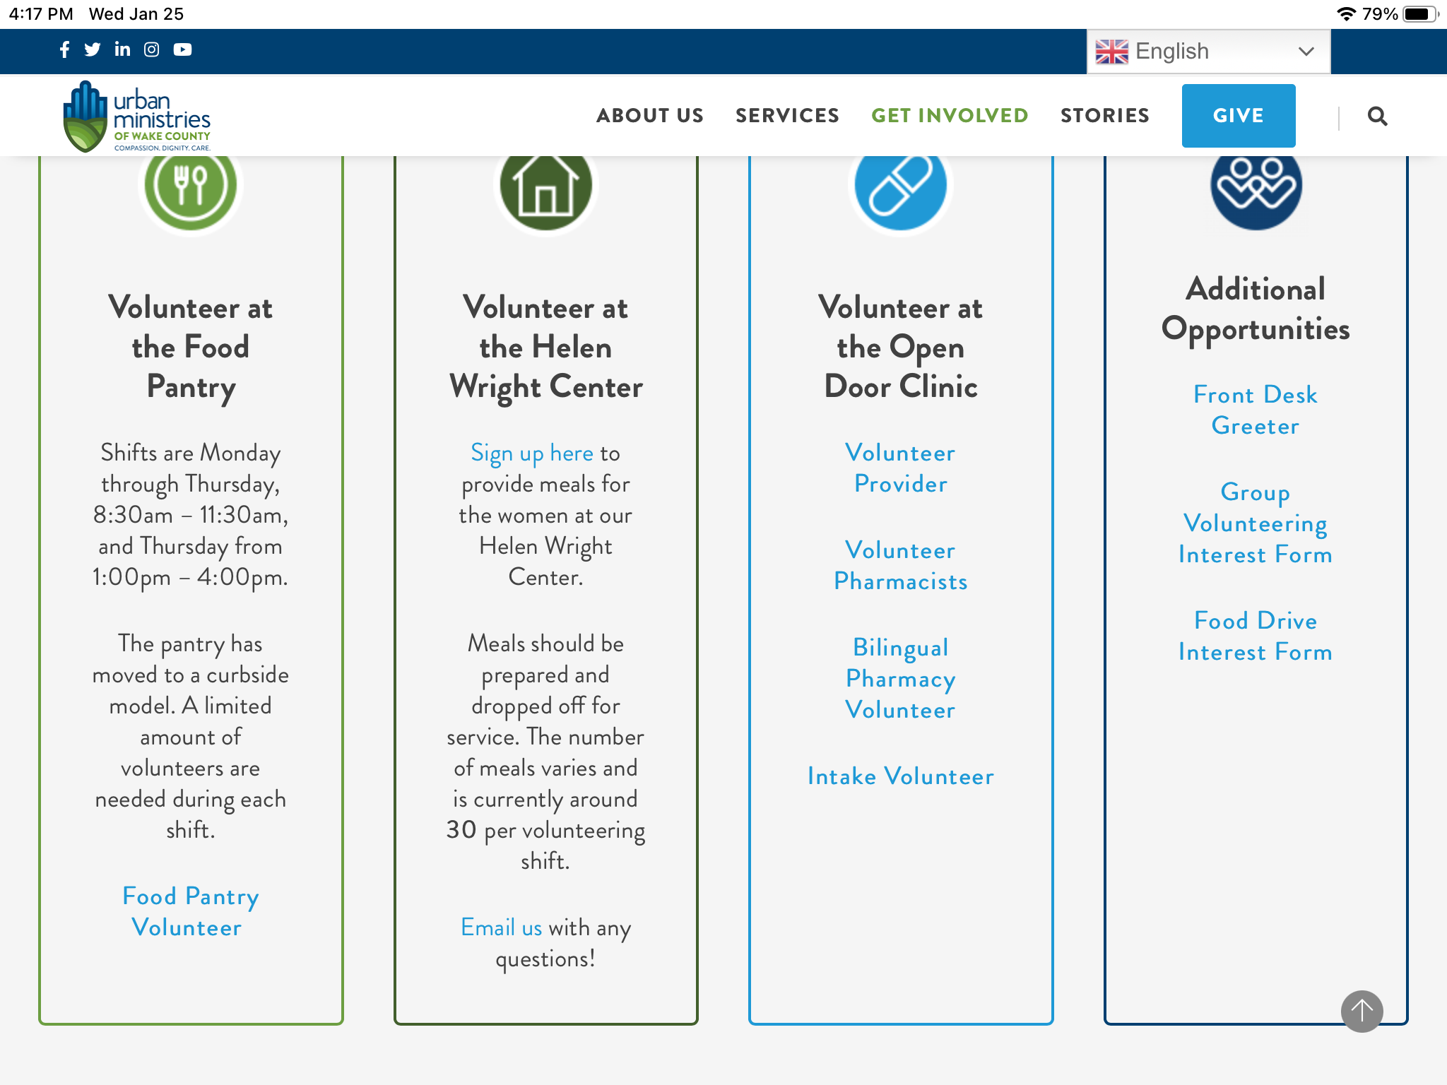
AARP
RALEIGH-WAKE COUNTY CHAPTER #3689
MEMBERSHIP RENEWAL FORM
2023

Chapter membership dues are $10.00 per year. You must be a member of the National AARP. Please complete this form below, make your check out to Wake County Chapter #3689 and mail it to –
Brenda Smith
8309 Amador Way
Raleigh, NC 27616

Member Name ___________________________________ Date ________________________

Address ______________________________________________________________________

What year did you join Chapter #3689? _____________________________________________

Phone # ____________________________ E-mail ___________________________________

National AARP Membership Number ____________________________ Exp. Date _________

Are you a Veteran? Yes ______ No______ (Our Veterans will be recognized in November.)

If you are interested in joining one of our committees, please contact the committee chair listed on the website or list the committee name below and someone will contact you:
Committee name _______________________________________________________________

Karen Youmans & Kelly Vick
Membership Co-Chairs

