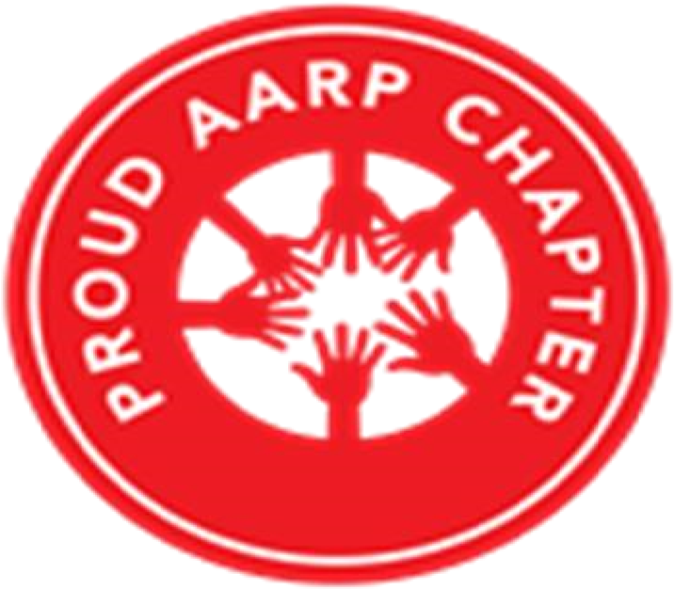 | THE CHRONICLE  RALEIGH-WAKE COUNTY CHAPTER #3689  http:AARPchapter3689.weebly.com  aarp3689@gmail.com  Kelly Vick - Editor  May – June 2022
June 16th  Picnic in the Park  Peter Williams Park  1601 Lynn Road  Raleigh, NC 27612  ******************************  Chapter Officers  Co-Presidents  Gayle Gayton  Willi Webb  Vice President  Cordelia Blackwell  Co-Secretaries  Hannah Gathings  Claude Lee  Pat Toothman  Gwenn Weaver  Co-Treasurers  Cynthia Bradley  Claudia Harris  Nominating  Allan Younger  ******************************  Committees  Community Service (Oweida Cole)  Fundraising (Lorrie Berlenbach)  Legislative (Karen Clark)  Membership (Karen Youmans)  Program (Allan Younger)  Sunshine (Claude Lee)  Telephone (Pat Toothman)  Staff Coordinates  Ambassador (James Hines)  Historian (Thelma Blake)  Newsletter (Kelly Vick)  Reflections (Grace Krishnamurty)  Webmaster (Claudia Harris) |  |  | MESSAGE FROM OUR VICE PRESIDENT  (Cordelia Blackwell)  ♪♪♫ Getting to know you – getting to know all about you… ♫♪♪  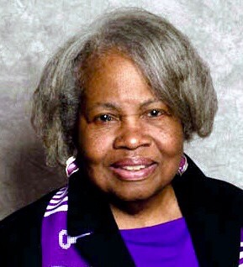  Since I have been a member of our AARP Chapter, there are so many attention-grabbing people I wanted to know more about. So when I was asked to write an article for the Chronicle, I thought this is an excellent opportunity to learn about members with an interview - which it should be an interesting topic. So here is my interview with Willi Webb:  Cordelia: Where did you grow up and how did you get to the Raleigh area?  Willi: I grew up in Colchester Connecticut, a small town in the middle of the state. I came to Raleigh about 30 years ago for a job change.  Cordelia: Did you come from a small or large family and tell us about your family now.  Willi: I guess you can say that I come from a large family. I grew up with five sisters. Four are still living.  Cordelia: You are such an intelligent person, tell us about your educational background.  Willi: I received a Bachelor’s degree from the University of Connecticut at Storrs, about 30 miles from home. I also have a Master’s in Education from Southern Connecticut in New Haven Connecticut. In addition, I have done post graduate studies at the University of Massachusetts, University of Pittsburgh, and NC State University.  Cordelia: I know you have had an extensive career, what are some of the positions you have had?  Willi: I have worked over 45 years in education in three states and the District of Columbia. I taught almost every grade from kindergarten to eighth grade. I served as a supervisor of elementary teachers, curriculum specialist, Director of Early Education, assistant principal, and in the US Department of Education in the Elementary and Secondary Education. I ended my career in the Wake County Schools as Director of Title I, a federally funded program for low achieving students.  Cordelia: Do you enjoy traveling and are there places you found interesting?  Willi: Yes, I enjoy traveling and am particularly fond of the beach and historic sites.  Cordelia: What is your favorite color, food, book, and movie?  Willi: Love anything in the pink/purple family although I am now attracted to the aqua colors. Aqua goes well with pink and purple. I am afraid that I enjoy most foods and that creates a problem---always struggling with controlling my weight. I read mysteries and am not a fan of movies. But, I enjoy live plays and performances.  Cordelia: What are your hobbies?  Willi: Currently, I am spending my time quilting and working in the yard.  Cordelia: Many thanks Willi! ♫♪♬ Getting to know you... ♪♫♪
In Loving Memory of one of our Faithful Chapter Members
Barbara Elaine Faison
(March 12, 1956 – May 14, 2022)

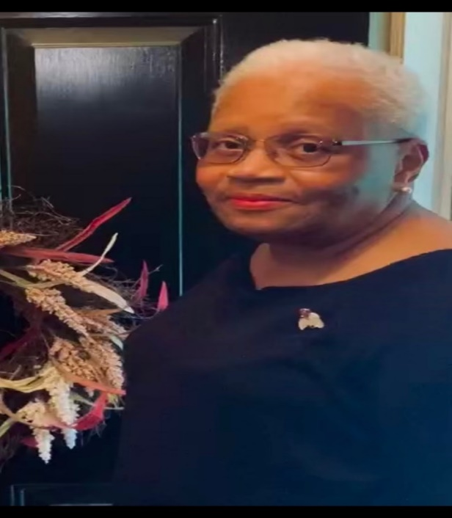
Barbara was born in Clinton, North Carolina to Johnnie Lee (deceased) and Susie P. Faison. She graduated from Union High School in Rose Hill, North Carolina. Immediately after high school, she relocated to Raleigh to attend Hardbarger Business College where she graduated in 1975. She continued her education by completing course work in Accounting at Wake Technical Community College and North Carolina State University. After serving 30-plus years in Business Administration, Barbara retired from Progress Energy, formerly Carolina Power & Light in 2008.

After retirement, Barbara kept busy by providing exemplary efforts through volunteerism in many organizations. In 2017, she received the AARP Andrus Award for Community Service, which is presented annually to one esteemed volunteer or couple in each state who displays an outstanding commitment to their communities by executing the vision and purpose of AARP. Recipients of this prestigious award share their experience, talent and skills to enrich the communities in which they serve. In 2019, Barbara received the North Carolina Extension & Community Association, Inc. Award of Excellence for educational and organizational achievement in fulfilling the mission and purpose of NCECA, Inc.

Barbara served on Chapter #3689 Community Service and Telephone Committees for many years and stayed true to her calling as a volunteer throughout the years, even as she endured health challenges. She never complained and always encouraged others to do the same. There are countless organizations for which Barbara served; however, below are a few in which she remained active until her transition:

Wake County Public Schools (Millbrook High School) – Volunteer, Mentor, Business Alliance Committee Member
NC Extension & Community Association (ECA) First Friday Club – Member and former Treasurer
Meals on Wheels of Wake County – Volunteer with Stomp Out Hunger Campaign
Sisters Network Triangle NC – Member and Breast Cancer Prevention Advocate
AARP – Chapter #3689 Member, Regional and State Volunteer
Wake County Board of Election – Voting Official
Garner Performing Arts - Volunteer
(2)

COMMITTEE REPORTS
SUNSHINE
Birthday cards were mailed to our members listed below who have birthdays in May and June. Sympathy cards were mailed to Brenda Bennett for the death of her brother; the Faison family for the death of Barbara Faison and also in memory of Barbara, a $25 donation was given to her Sunday School Class. A get well card was mail to Mary Weathers. If you know of anyone who is ill or a bereaved family, please call Claude Lee (919-971-3317) or e-mail him at claudealeejr@gmail.com.
MAY BIRTHDAYS |  | JUNE BIRTHDAYS
Evelyn Hines (10) |  | Rufus Henry (4)  Ilse Anke (18)  Karen Youmans (18)  Judi Dawson (24) | Emma Dorssett (26)  Lorrie Berlenbach (26  Jacqualine McCullough (27)

MEMBERSHIP
If you have not renewed your 2022 membership, it is not too late. Our chapter membership dues are $10.00 per year. You must be a member of the National AARP and you will need your national membership card to complete the membership form. The membership form is on our website with instructions on where to mail it.

COMMUNITY SERVICE
The Food Pantry is one of our continuing monthly activities. In fact, because we have been participating with Urban Ministries more than two years and have completed over 200 hours, Oweida Cole was recognized as a STAR and received a Volunteer T-Shirt in May.

Actually, May has brought numerous "flowers" and assistance as results of the April showers. We donated bed sheets and towels to a person who has recently been evicted from their home. Toys (from Karen Clark) and bags of clothing were presented to Healing Transitions. Other agencies were given bed linens as well.

Loaves and Fishes celebrated their 40th Anniversary on Saturday, June 11 from 11:00 am - 1:30 pm at Dorothea Dix Park. Lunch was served, pictures taken, games, snacks, music, brief presentations, in addition to guest artist, entertainers, monetary donations and more. It appears that a good time was had by all......

Wake Up and Read has a Community Volunteer Training on Monday, June 13 from 6:00 -7:30 pm. This training will be held virtually and if you are interested in the sign-up link, contact Oweida Cole (919-803-7569).

NOMINATING
We have one vacancy for a Co-President. This person will be working in partnership with another person as the leaders of this Chapter.

FUNDRAISING
Fundraising Committee is in the process of planning the Jazz Event for September, 2022. You will receive an email this month to assess your level of commitment for this fundraising effort.

LEGISLATURE
With all the political clutter in the news headlines vying for our attention, the 2022 elections will be decided by voters aged 50 and over. Older Americans consistently turn out in greater numbers than any other age group and 2022 is expected to be no different. You have the experience and dedication needed to select the candidates best equipped to represent the needs of your families and communities. AARP is here to help you find the answers you need about voting in 2022, so we are excited to introduce you to TurboVote. This is an amazing online tool that lets you sign up for personalized notifications that include; information on voter registration in your state, updates on local voting procedures (including helping you start absentee or mail-in ballot requests), details on what you need to cast your vote and reminders of primary and general election dates. For more information go to this website - https://votingtool.aarp.org/?cmp.

TELEPHONE
Monthly calls are continually being made to all members as a way to keep in touch and discuss Chapter news. June calls included “Picnic In The Park” and taking box lunch orders for the Picnic. Thanks to Cordelia Blackwell for volunteering as a “Caller”.
Beautiful Flowers from AARP Chapter #3689 Members

Flowers from Gayle Gayton’s Yard
(Top left - Rose Bush & Top right - Cone Flower & Vinca = Bottom left - Hibiscus & Bottom right - Hydrangea)
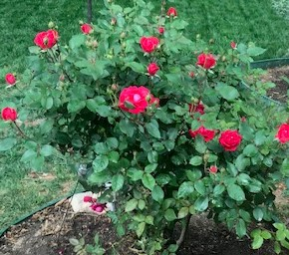 | 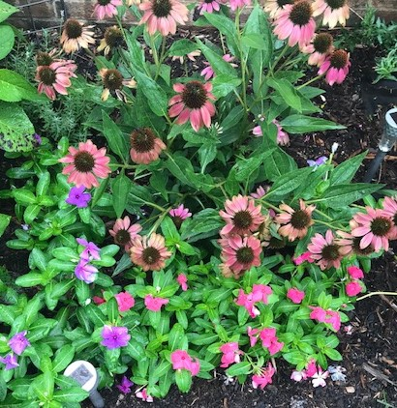
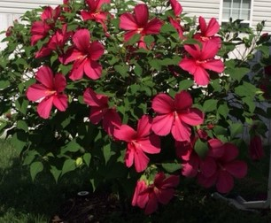 | 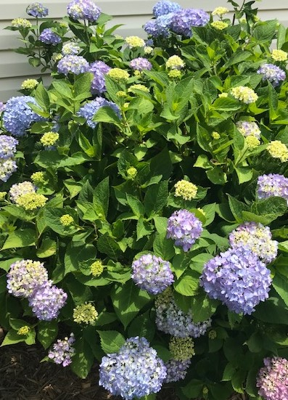

Knock Out Rose Bush  (Stewart & Kelly Vick’s Back Yard) |  | Rose Campion  (Submitted by Gayle Gayton from the Arboretum)
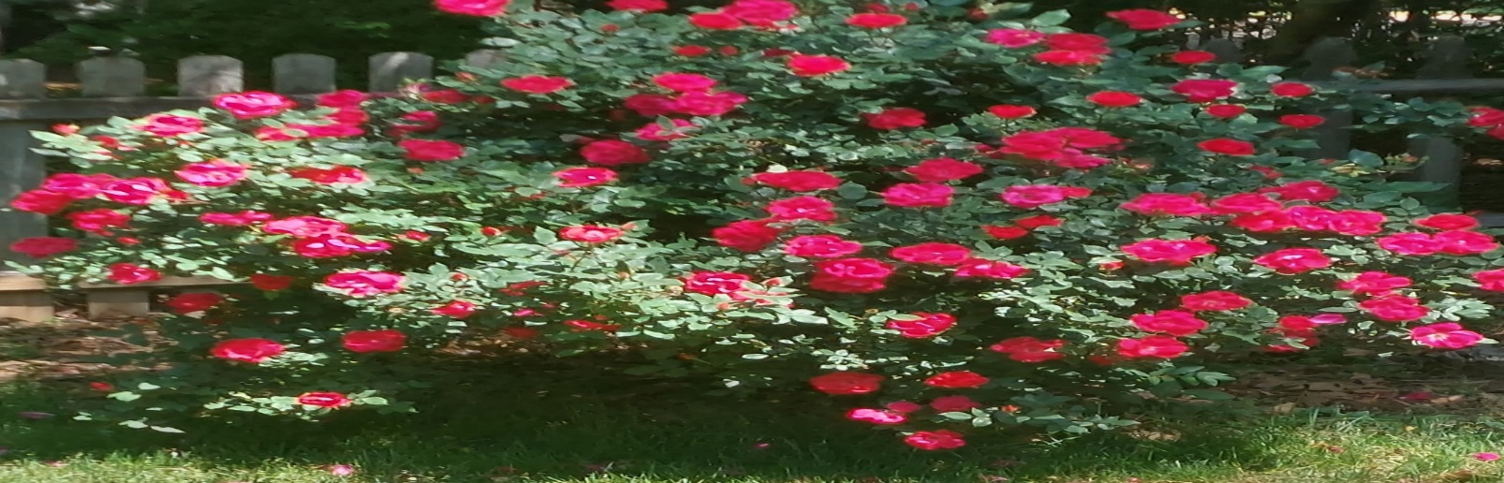 |  | 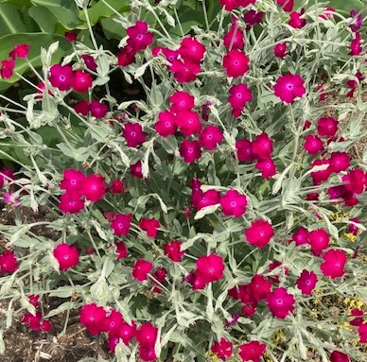
A special request for this recipe:
Oreo Cheesecake Bars

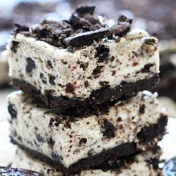

These Oreo Cheesecake Bars will give you that delicious taste of cheesecake that you know and love, without the difficulty and stress of an entire cheesecake. They are easy and quick to make and will impress anyone that eats them! (15 -18 Bars)

Ingredients
- 19.1 oz package regular Oreo cookies
- 1/4 cup {1/2 stick} salted butter melted
- 3 {8 oz} packages cream cheese softened
- 3/4 cup granulated sugar
- 3/4 cup sour cream room temperature
- 1 tsp. vanilla extract
- 1/2 tsp. salt
- 3 large eggs room temperature

Instructions
- Preheat oven to 325ºF and line a 9x13 inch pan with aluminum foil, leaving a 2-inch overhanging on both sides. Spray with cooking spray and set aside.
- Place 28 Oreos in a food process and pulse until finely ground. Add the melted butter and stir until the crumbs are completely coated.
- Evenly press the cookie mixture firmly into the prepared pan. Bake for 10 minutes and transfer to a wire cooling rack.
- Roughly chop the remaining Oreos, either by pulsing a few times in a food processor, or chopping by hand.
- In a large bowl, use an electric mixer to beat the cream cheese on medium speed. Once smooth and creamy, add the sugar and blend well, about 2 minutes. Scrape down the sides as needed.
- Beat in the sour cream, vanilla, and salt. Scrape the bowl and mix again.
- Add the eggs, one at a time, beating well after each addition. Scrape down the sides and then beat again, making sure the mixture is fulling combined.
- Gently fold in the Oreos and mix well.
- Pour the cream cheese mixture over the crust and smooth out on top. Bake for 40 minutes, until filling is slight wobbly in the middle and set on the outside.
- Move to a wire rack and let cool completely, about 1 hour. Once cooled, chill in the refrigerator for at least 3 hours.
- Once cooled, lift from pan, using foil overhanging and cut into squares. Keep refrigerated until ready to serve.
Note: Cheesecake tastes better as time goes on, so for prime taste, I suggest making these the day before you plan to eat them.

**************************************************************************************************
If you have a story or great ideas that you think may be of interest to our members, please e-mail them to Kelly Vick (sandkvick@nc.rr.com) and your point of interest will be listed in The Chronicle. See Examples below:
Silver Lining Story
Favorite Recipe
Statement about something special and exciting that happened to you.

